**Unit 2: Body Systems, Genetics, Microorganisms and Health**

B2.2 Circulatory System

|  |  |  |  |
| --- | --- | --- | --- |
| **Content - CCEA Double Award Biology 2 – Fort Hill Integrated College** | Got it | Nearly | Haven’t a clue |
| **B2.2 Circulatory System** | | | |
| **Blood components** | | | |
| Can you use a microscope to examine a blood smear, identify the component parts and demonstrate understanding of their function?   * red cells are a specialised cell adapted to oxygen transport – biconcave shape, absence of nucleus and haemoglobin containing iron; * white cells are a defence against disease; * platelets have a role in converting fibrinogen to fibrin, causing blood clotting and scab formation; and * plasma transports cells, food molecules, carbon dioxide, hormones and urea; |  |  |  |
| **Cell lysis** |  |  |  |
| **Can you demonstrate knowledge and understanding of the effect of placing red blood cells in water, causing cell lysis?** |  |  |  |
| **Blood vessels** |  |  |  |
| Can you describe the structure of blood vessels (arteries, veins and capillaries) and relate their structures to their functions, including:   * wall thickness; * presence of muscle and elastic fibres; * lumen diameter; and * presence of valves; and |  |  |  |
| Can you demonstrate knowledge and understanding of the role of the different types of blood vessel, including:   * arteries carrying blood under high pressure away from the heart (usually oxygenated blood); * veins carry (usually deoxygenated) blood under low pressure towards the heart with valves that maintain the direction of flow; and * capillaries allowing the exchange of material with tissues through permeable walls. |  |  |  |
| Can you name and demonstrate knowledge and understanding of the functions of blood vessels entering and leaving the heart, lungs, liver, kidneys and intestine, describing the sequence and direction of flow in double circulation of oxygenated and deoxygenated blood; |  |  |  |
| **Effects of exercise** |  |  |  |
| Can you describe how to investigate the effects of exercise on the pulse rate and describe how the circulatory system benefits from regular exercise – strengthened heart muscle and increased cardiac output when at rest; and |  |  |  |
| **The heart** |  |  |  |
| Have you examined the heart and related its structures to the function of a unidirectional pump, including identifying the four chambers, valves, thickness of muscle wall and coronary blood vessels. |  |  |  |

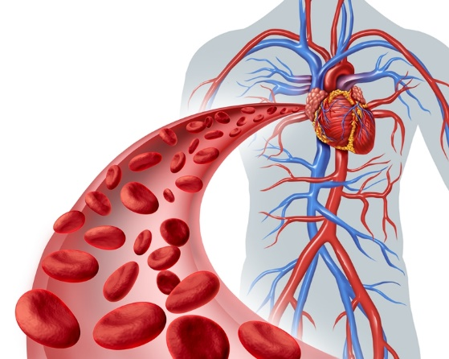The Circulatory system has 2 main functions: **Transport** of materials to and from cells,and **Protection against disease**. The circulatory system has 3 main components;

**The Circulatory system**

* The blood
* The blood vessels
* The heart

1. **Blood components: blood can be divided into 4 parts;**

* **Red blood cells** (r.b.c.) - specialised cell adapted to oxygen transport – biconcave shape, absence of nucleus and haemoglobin containing iron;

[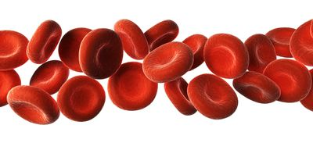](https://www.google.co.uk/url?sa=i&rct=j&q=&esrc=s&source=images&cd=&cad=rja&uact=8&ved=&url=https://www.thoughtco.com/red-blood-cells-373487&psig=AOvVaw3is9z5yW5dwG_2XYL5ZIEa&ust=1538836740159140)

* **White blood cells** - defend against disease;
* **Platelets** - have a role in converting fibrinogen to fibrin, causing blood clotting and scab formation; and;

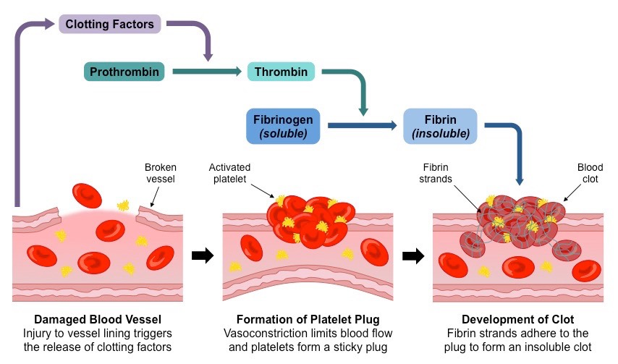

Platelets help convert fibrinogen to fibrin, causing blood clotting and scab formation

* **Plasma** – liquid part that transports cells, food molecules, carbon dioxide, hormones and urea;

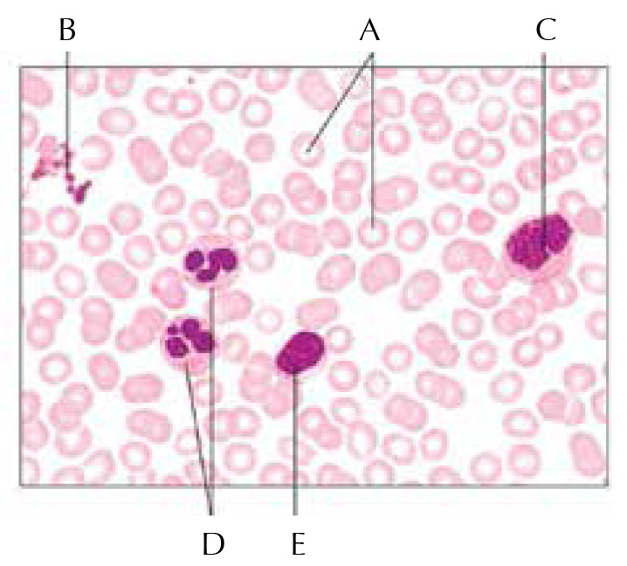

**Photomicrograph of a human blood smear showing red blood cells (A), platelets (B) and white blood cells (C, D; and E)**

**(H) Cell lysis: osmoregulation (controlling the amount of water in the body) is vital. If blood was to become too dilute (too much water in it), water would enter our cells (r.b.c) by osmosis and the cells would burst (lysis) (N.B. – plant cells don’t have this problem as their cell walls prevent this.**

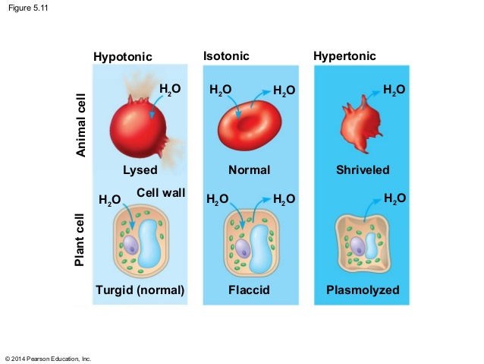

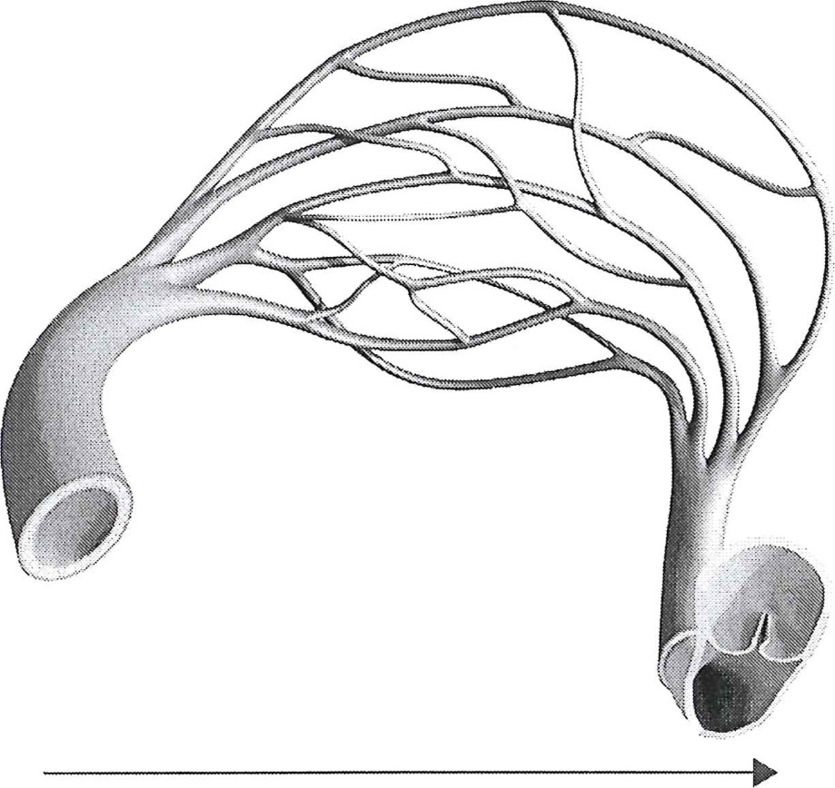**2. Blood vessels**

There are 3 different types of blood vessel;

* Arteries - carry blood under high pressure away from the heart (usually oxygenated blood);
* Veins - carry (usually deoxygenated) blood under low pressure towards the heart with valves that maintain the direction of flow; and
* Capillaries - allow the exchange of material with tissues through permeable walls.

Each type of blood vessel has an adapted structure relating to its function;

|  |  |  |  |
| --- | --- | --- | --- |
|  | **Arteries** | **Veins** | **Capillaries** |
| Function | Carries blood …………… from heart under ………… pressure | Carries blood …………… to the heart under ………… pressure | Here materials are ……………………… between the blood and the cells |
| Wall thickness |  |  | Tiny (one cell thick) |
| Presence of muscle and elastic fibres |  |  |  |
| Lumen diameter |  |  |  |
| Presence of valves? |  |  |  |
| Diagram |  |  |  |

[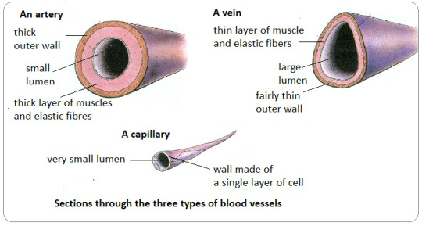](https://pmgbiology.files.wordpress.com/2015/02/3289630_orig.jpg)

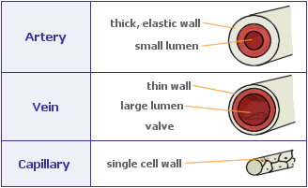

**3. The Heart**

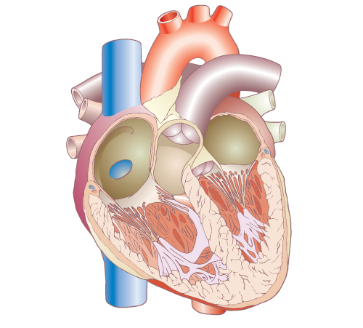The heart pushes blood around the body. It is really 2 pumps with …… separate chambers. All mammals have a …………………… circulatory system. The ……………… side of the heart pumps blood to the …………… to collect …………………… and excrete ……………… …………………… The thicker left side pumps blood to the rest of the ……………… (so needs to be more muscular). ………………… separate the ventricles from the atria and are also situated in the arteries leaving the heart. These prevent backflow and ensure that the heart acts as a unidirectional pump. The heart itself receives blood from the ………………… arteries.



[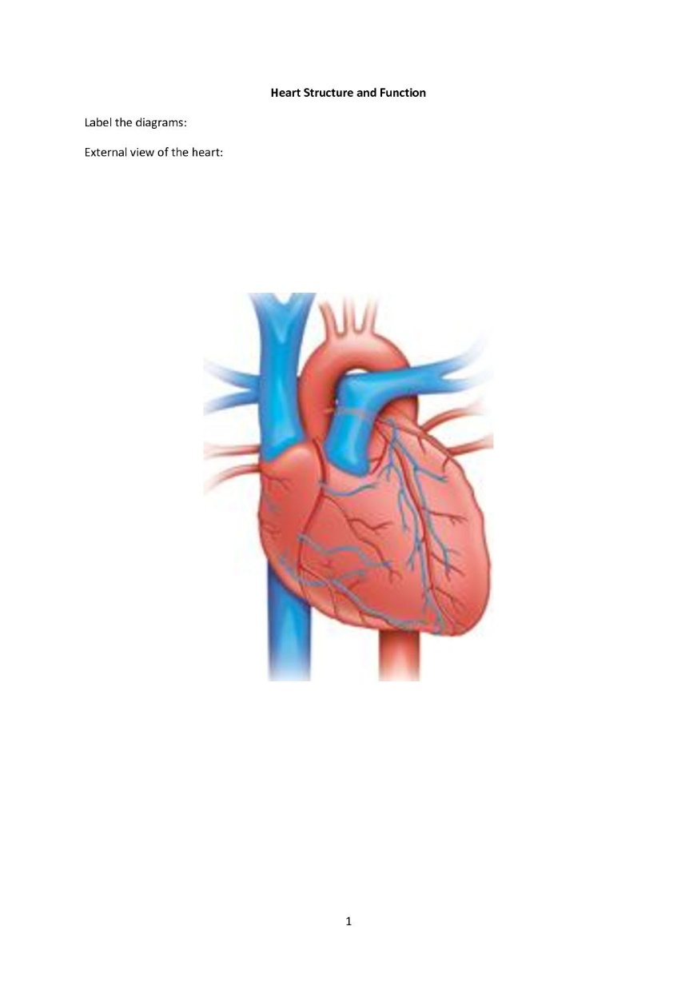](http://www.google.co.uk/url?sa=i&rct=j&q=&esrc=s&source=images&cd=&cad=rja&uact=8&ved=2ahUKEwjaoPje5YjeAhXNJ1AKHUKEC4UQjRx6BAgBEAU&url=http://www.6weeks.co.uk/external-heart-diagram-unlabeled.html&psig=AOvVaw1pyJb7XRrC2JMf36pqaCxK&ust=1539704723953379)

Double Circulation

Humans (like all mammals) have a **double circulation**. This means that blood travels twice through the heart to go round the body once. Deoxygenated blood returns from its journey around the body to the right side of the heart. From here it is pumped to the lungs to pick up oxygen and excrete CO2. This oxygenated blood is then directed to the left side of the heart from which it is pumped to the rest of the body.

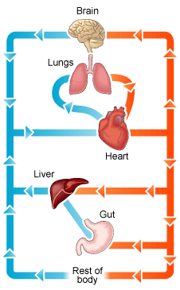

Kidneys

Mesenteric artery

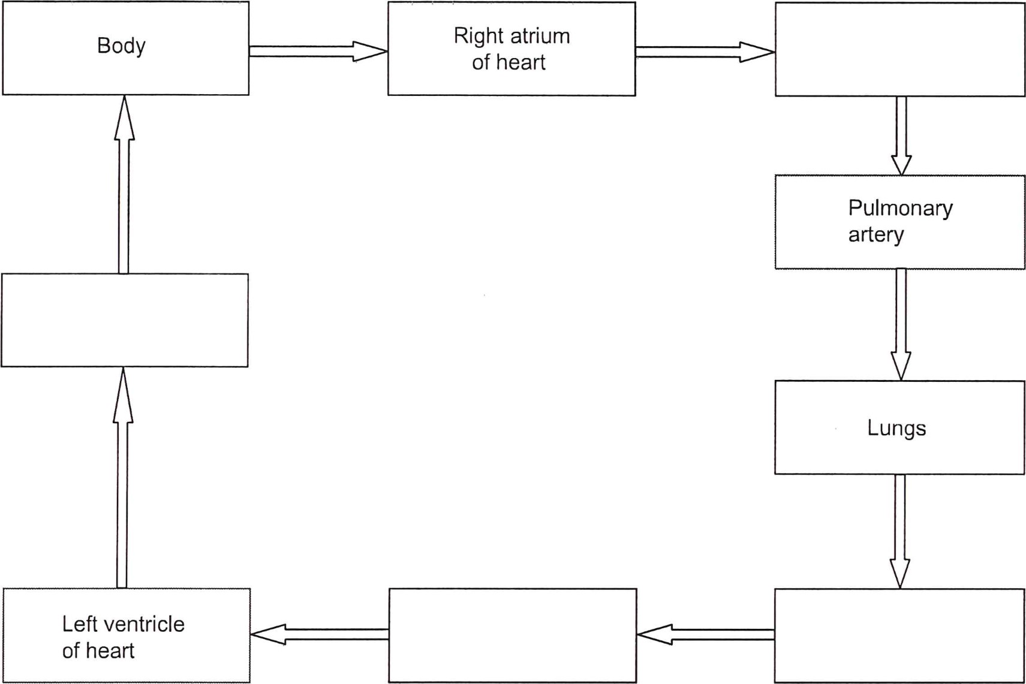

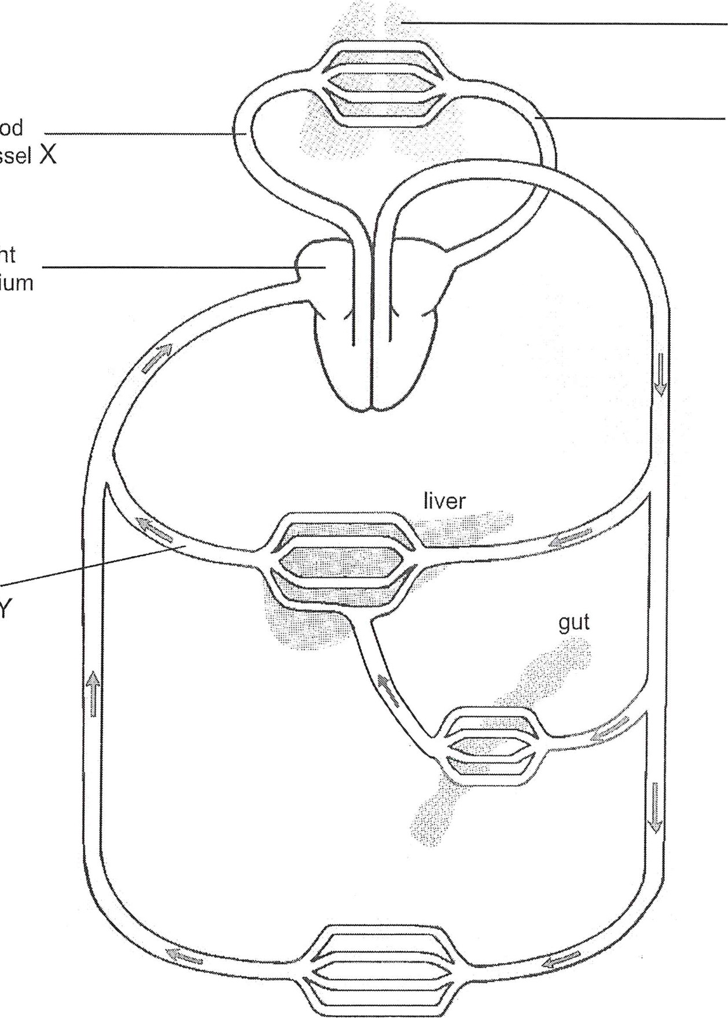

blood

right

atrium

vessel

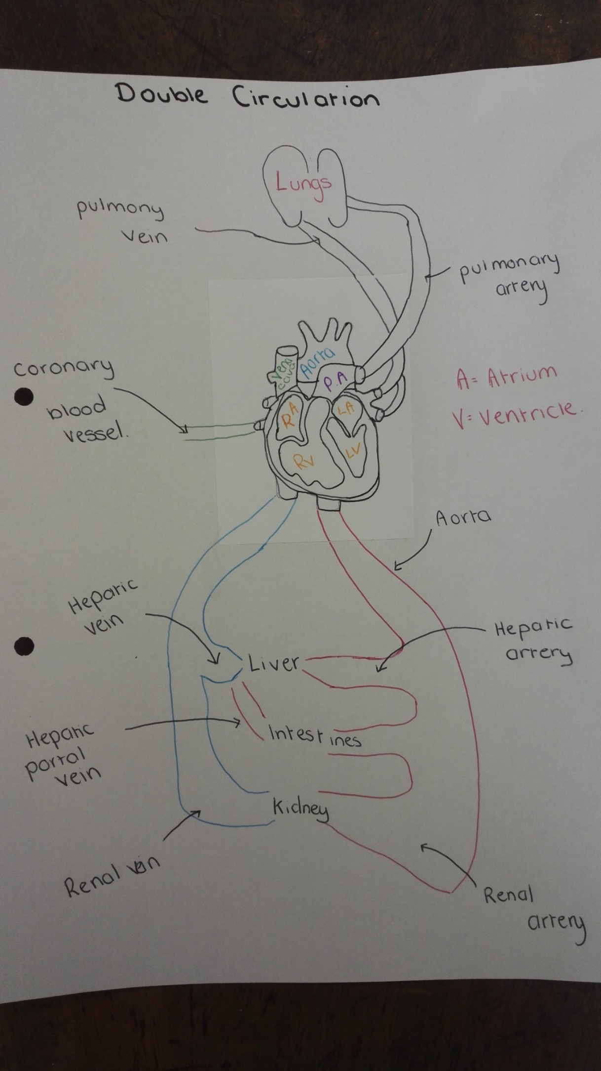

**Investigating the effects of exercise on the Circulatory system**

|  |
| --- |
| ILO: by the end of this lesson you should be able to;   * describe how to investigate the effects of exercise on the pulse rate? |

[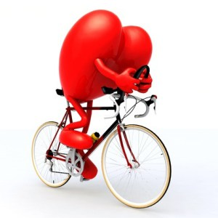](https://www.google.co.uk/url?sa=i&rct=j&q=&esrc=s&source=images&cd=&cad=rja&uact=8&ved=2ahUKEwjMgcWvlI3eAhWDTcAKHYWqA7wQjRx6BAgBEAU&url=https://www.amboyguardian.com/2014/11/27/healthy-heart-event-2/&psig=AOvVaw1SjsKaRSrPav6cVMcpzBOr&ust=1539854794961165)

Hypothesis:

I want to find out if …………………………………………………………………………………………………………

Variables:

* Independent variable – The variable I am changing is the …………………
* Dependant variable – the variable I will measure is the ……………………
* [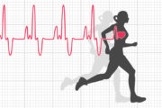](https://www.runnersworldonline.com.au/wp-content/uploads/2017/04/shutterstock_446251636-e1493176994730.jpg)Control variables – I will keep the same;
  + ……………………………………………………………………………
  + ……………………………………………………………………………

List of apparatus:

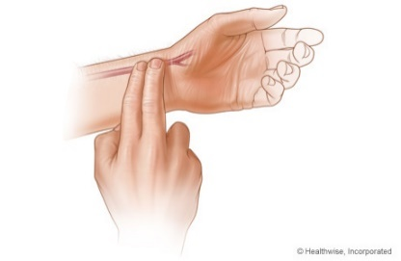Method:

1. After 1 minute of quiet sitting, measure your resting pulse rate and record your result
2. ……………………………………………………………………………………………………
3. ……………………………………………………………………………………………………
4. ……………………………………………………………………………………………………
5. ……………………………………………………………………………………………………

[](http://canitz.info/crash-test-dummies-cartoon/car-crash-dummy-cartoons-and-ics-funny-pictures-from-cartoonstock-crash-test-dummies-cartoon/)Risk assessment

* What are the possible dangers? …………………………………………………………………………………………

.............................................................................................

* How could they hurt someone? …………………………………………………………………………………………

.............................................................................................

* How can you limit the risk? …………………………………………………………………………………………

.............................................................................................

Table (headings / units):

|  |  |
| --- | --- |
| **Type of exercise** | **Pulse rate (……..)** |
| Rest |  |
|  |  |
|  |  |
|  |  |
|  |  |

[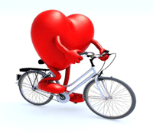](http://cholesterol.ygoy.com/2013/01/22/what-type-of-exercise-is-best-to-reduce-heart-risk/)Presentation: Draw a bar chart to display your results

Conclusion: As we increase physical intensity, our heart rate increases/decreases.

Explanation: ………………

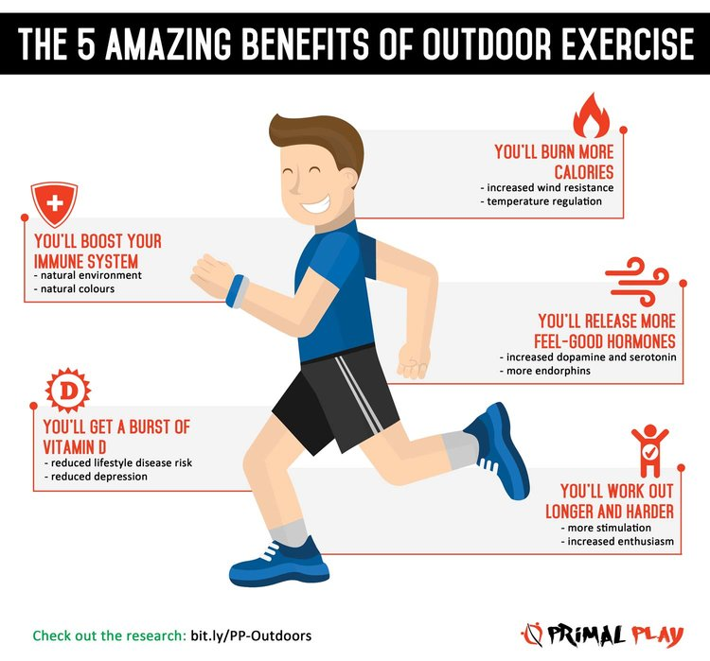**The benefits of exercise**

|  |
| --- |
| ILO: by the end of this lesson you should be able to;   * describe how the circulatory system benefits from regular exercise – strengthened heart muscle and increased cardiac output when at rest |

Regular exercise benefits the circulatory system in a number of ways. Exercise helps by strengthening the heart muscle (as with any muscle that is exercised). A stronger heart will have an increased **cardiac output** (pumps more blood per minute) even when not exercising.

**Cardiac output = the volume of blood pumped by the heart per minute**

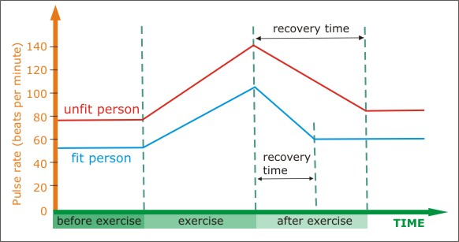

The **recovery rate** is the time it takes for the pulse (heart) rate to return to normal after exercise and this will usually be shorter for a fit person.

1. Which person is fitter? Red or blue?
2. Suggest 3 pieces of evidence to support your choice: