Chemistry Unit C1: Structures, Trends, Chemical Reactions, Quantitative Chemistry and Analysis
C1.3 Structures
Content - CCEA Double Award Chemistry 1 – Fort Hill Integrated College | Got it | Nearly | Haven’t a clue
C1.3 Structures
Ionic structures
Can you use the accepted structural model for giant ionic lattices to explain the physical properties of ionic substances such as sodium chloride, including melting point, boiling point and electrical conductivity (diagram of giant ionic lattice is not expected);
Can you recall that most ionic compounds are soluble in water;
Molecular Covalent structures
Can you use the accepted structural model for molecular covalent structures to explain the physical properties of molecular covalent structures such as iodine and carbon dioxide, including melting point, boiling point and electrical conductivity;
Can you demonstrate knowledge and understanding that the intermolecular forces between covalent molecules are weak forces called van der Waals’ forces;
Can you recall that many covalent molecular substances are insoluble in water;
Giant covalent structures
Can you demonstrate knowledge and understanding of the giant covalent structure of carbon (diamond) and carbon (graphite), and predict and explain their physical properties, including:
- electrical conductivity;
- hardness;
- melting point and boiling point; and
- their uses in cutting tools (diamond), lubricants and pencils (graphite);
Metallic structures
Can you use the accepted structural model for metals to predict and explain their structure and physical properties including melting point, malleability, ductility and electrical conductivity.
Can you demonstrate knowledge and understanding that an alloy is a mixture of two or more elements, at least one of which is a metal, and the resulting mixture has
metallic properties;
Structure and bonding of carbon
Can you demonstrate recall that carbon can form four covalent bonds;
Can you demonstrate knowledge and understanding of the structure of graphene (a single atom thick layer of graphite), explain its physical properties, including strength and electrical conductivity, and recall its uses such as those in batteries and solar cells;
Can you demonstrate knowledge and understanding of the meaning of the term allotrope as applied to carbon (diamond), carbon (graphite) and graphene; and
Classification of structures
Can you use given information to classify the structure of substances as giant ionic lattice, molecular covalent, giant covalent or metallic.

C1.4 Nanoparticles
Content - CCEA Double Award Chemistry 1 – Fort Hill Integrated College | Got it | Nearly | Haven’t a clue
C1.4 Nanoparticles

Can you recall that nanoparticles are structures that are 1–100 nm in size and contain a few hundred atoms; and
Can you evaluate the benefits of nanoparticles in sun creams, including better skin coverage and more effective protection from the Sun’s ultraviolet rays, and the risks, such as potential cell damage in the body and harmful effects on the environment.

C1.3 Structures
The bonding of a structure determines its physical properties. There are 3 types of bonding: I……………, C………………… and M………………..
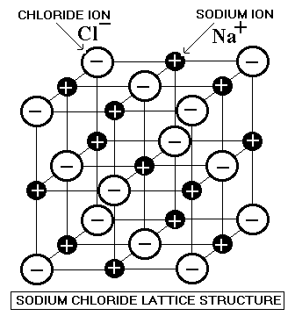
The Ions in an Ionic lattice are held together because of …………………………………………………………………………
………………………………………………………………………………………………
- Because each cation is bonded to 6 anions, Ionic compounds are …………………… (white) but brittle.
- Because the ions can’t move, Ionic compounds do not ………………… ………………………… unless dissolved or molten
- Ionic compounds ………………… (are soluble) in water
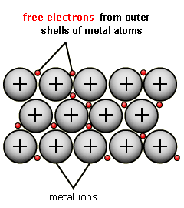
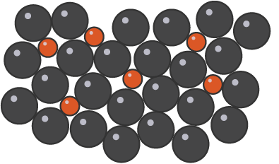
Metallic bonding results from the attraction between the …………………. ions in a regular lattice and the ……………………… electrons. As these layers of ions can ……………… over each other, metals are …………… and ……………………. To make them stronger we can add other elements to them when molten. This ……………………… the regular pattern when solid and makes them stronger.
An Alloy is defined as a mixture of 2 or more elements, at least one of which is a ………………………, and the resulting material has metallic properties.
Covalent structures
There are 2 types of covalently bonded structures; Simple and Giant
- Covalent molecules (Simple) – are small groups of atoms e.g.
- H₂, O_{2,} N_{2,} Cl_{2,} F_{2,} Br_{2,} I₂ (diatomic)
- H₂0, CH₄, NH₃
Properties
- Most are gases (low melting and boiling points) because the intermolecular forces between covalent molecules are weak forces called van der Waals’ forces.
- Covalent molecules cannot conduct electricity as there are no charged particles.
- Most covalent molecules are insoluble in water.

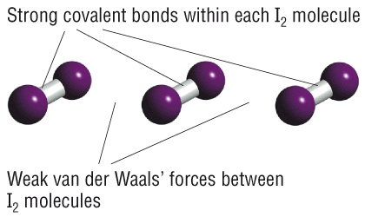

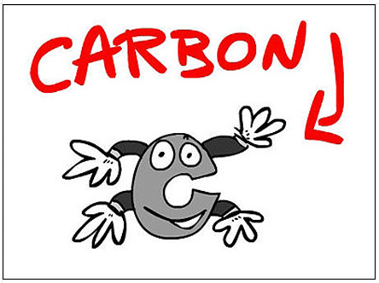
- Giant covalent structures
Carbon is a non-metal and each Carbon atom can form four covalent bonds. There are 3 allotropes (different physical forms in which an element can exist) of carbon. Diamond, Graphite and Graphene.
An allotrope is a different form of the same element in the same physical state.

The 3 allotropes of Carbon
 | Diamond | Graphite | Graphene
Bonding | 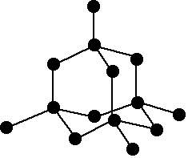 | 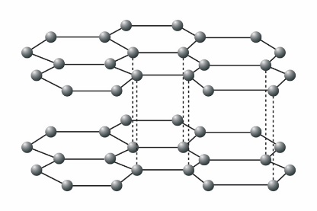 | 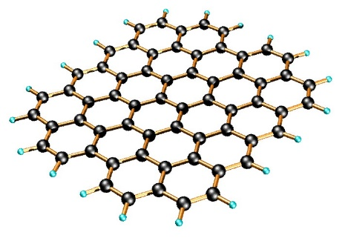
 | Each Carbon atom is bonded to four others making it very hard | Each carbon atom is bonded to 3 others. There are only weak van der Waals forces between the layers. Graphite has delocalised electrons | A single atom thick layer of graphite. Has delocalised electrons.
Melting and boiling point | High | High | High
 | Many covalent bonds which require lots of heat to break them
Electrical conductivity | Doesn’t conduct (no ions or free electrons) | Good conductor | Good conductor
 |  | (has delocalised electrons)
Hardness /strength | Hard | Soft (weak forces between layers) | Very strong
Uses | Cutting tools | Lubricants for machinery and in pencil leads (as the layers slide over each other which leaves a visible mark on a page) | It is light, strong, cheap conductor. Future uses include solar cells and batteries.

Properties of materials
 | Ionic (Group I&II with VI&VII) | Simple Covalent molecule  Molecular covalent | Giant Covalent Structures | Metals
Normal state | White solid  brittle | Gas (except H₂O) | Solid | Solid (except Hg)  malleable
Melting points | High | Low  Weak vdW between molecules – only a little energy needed to break bonds | Very High  (strong bonds between atoms need a lot of energy to be broken) | High
Boiling points | High | Low | Very High | High
Solubility | Soluble in water | Insoluble | Insoluble | Insoluble
Conductivity | No as solid  Yes molten or dissolved  (IONS CAN MOVE) | No | Most no  Graphite is the only non-metal conductor (DELOCALISED ELECTRONS can move and carry charge) | Yes  (DELOCALISED ELECTRONS)

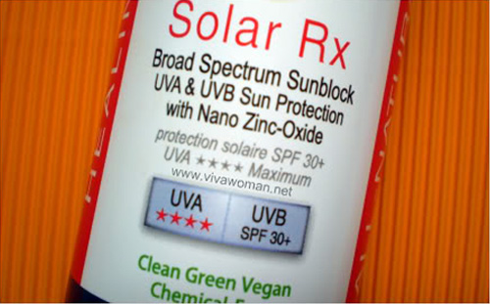
Nanoparticles

1 nanometre (1nm) = 1 x 10⁻⁹ metres (= 0.000 000 001m or a billionth of a metre)

A Nanoparticle is a structure that is 1–100 nm in size and contain a few hundred atoms. Nanoparticles have very different properties and uses from the bulk material. This is due to their high surface area to volume ratio.

Examples
- Silver nanoparticles have antiseptic properties so are used in medical dressings and in clothing to kill bacteria
- Zinc oxide and Titanium oxide nanoparticles are used in modern sun cream
- Cosmetics
- Gold Nano-cages could deliver drugs to exactly where they are needed in the body
Sun cream is a product that absorbs some of the sun’s ultraviolet radiation and helps protect against sunburn. Traditional sun creams contain zinc oxide, a white solid that absorbs ultraviolet radiation but is difficult to rub in. Nanoparticles of zinc oxide are now often used in sun screams. They have several benefits:
- They give better skin coverage to the sun cream
- They give more effective protection from the sun’s ultraviolet rays
- They are clear and colourless (invisible on the skin) and,
- They do not degrade on exposure to the sun.
However, Nano-Science is relatively new and there may be unknown, unpredictable effects if these nanoparticles enter the bloodstream. It is often assumed that because the bulk material is safe to use that nanoparticles of the same material are also safe. The risks of using nanoparticles in sun cream include:
- Potential cell damage in the body – nanoparticles are so small they may be able to penetrate cell membranes, or be breathed in. In the body they may be more reactive or more toxic than the bulk material
- Harmful effects on the environment

