**Unit 2: Body Systems, Genetics, Microorganisms and Health**

B2.1 Osmosis and Plant Transport

**Homework Booklet** Name: ________________________________________

|  |  |  |  |
| --- | --- | --- | --- |
| **Content - CCEA Double Award Biology 2 – Fort Hill Integrated College** | Got it | Nearly | Haven’t a clue |
| **B2.1 Osmosis and Plant Transport** | | | |
| **Osmosis, Plasmolysis and Turgidity** | | | |
| *Investigate the process of osmosis by measuring the change in length or mass of plant tissue or model cells, using Visking tubing (****Prescribed Practical B5****);* |  |  |  |
| Can you identify changes in plant cell structure that occur in plasmolysed and turgid cells due to osmosis? |  |  |  |
| Can you explain osmosis as diffusion of water molecules from a dilute solution to a more concentrated solution, through a selectively permeable membrane? |  |  |  |
| Can you explain how osmosis causes plant cells to become plasmolysed and turgid and demonstrate knowledge and understanding of the role of the cell wall in  limiting the entry of water? |  |  |  |
| **The potometer** |  |  |  |
| *Use a potometer (bubble and weight potometer) to investigate the factors affecting the rate of water uptake by a plant and washing line method to investigate the factors affecting the rate of water loss from leaves (****Prescribed Practical B6****)*. |  |  |  |
| **Transpiration** |  |  |  |
| Can you define transpiration as evaporation from mesophyll cells followed by diffusion through airspaces and stomata? |  |  |  |
| Can you explain how surface area, wind, temperature, humidity and light intensity affect transpiration and the rate of water uptake by a plant? |  |  |  |
| **Uses of water** |  |  |  |
| Can you recall that plants use water for support, transport, transpiration and photosynthesis? |  |  |  |

**Osmosis**

Diffusion is the movement of any substance from a region of high concentration to a lower concentration.

Active Transport is the movement of a substance from a region of low concentration to a higher concentration. Unlike diffusion, it requires metabolic energy.

Osmosis is the diffusion of water from a dilute solution to a more concentrated solution, through a selectively permeable membrane.

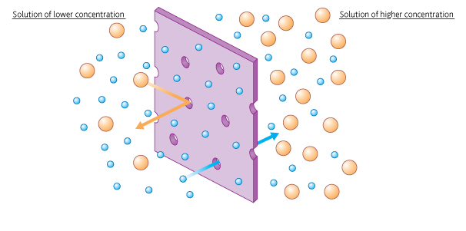

**Investigating how the concentration of salt solution affects the mass of potato cylinders.**

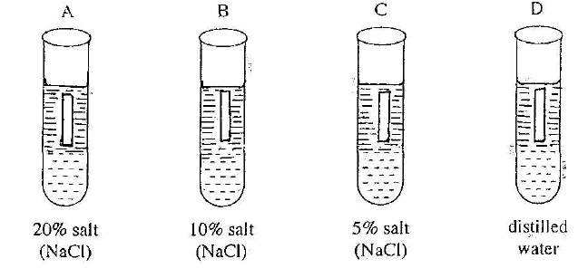

Independent variable: Salt concentration

Dependant Variable: Mass change of potato

Control Variables:

1. Time in the salt solution
2. Size of potato
3. Temperature of salt solution

|  |  |  |  |  |  |
| --- | --- | --- | --- | --- | --- |
| **Tube ref.** | **NaCl conc /%** | **Mass of cylinders/g** | | | **Change in mass / %**  **(note if it is + or -)** |
| **Initial** | **Final** | **Change** |
| A | 0 | 2.31 | 2.38 | +0.07 | +3% |
| B | 1 | 2.20 | 2.22 | +0.02 | +0.9% |
| C | 2 | 2.59 | 2.50 | -0.09 | -3.47% |
| D | 3 | 2.40 | 2.30 | -0.10 | -4.17% |
| E | 4 | 2.54 | 2.37 | -0.17 | -6.69% |
| F | 5 | 2.46 | 2.23 | -0.23 | -9.35% |

**percentage change in mass = [(final mass – initial mass)/initial mass] × 100**

**Graph of results**

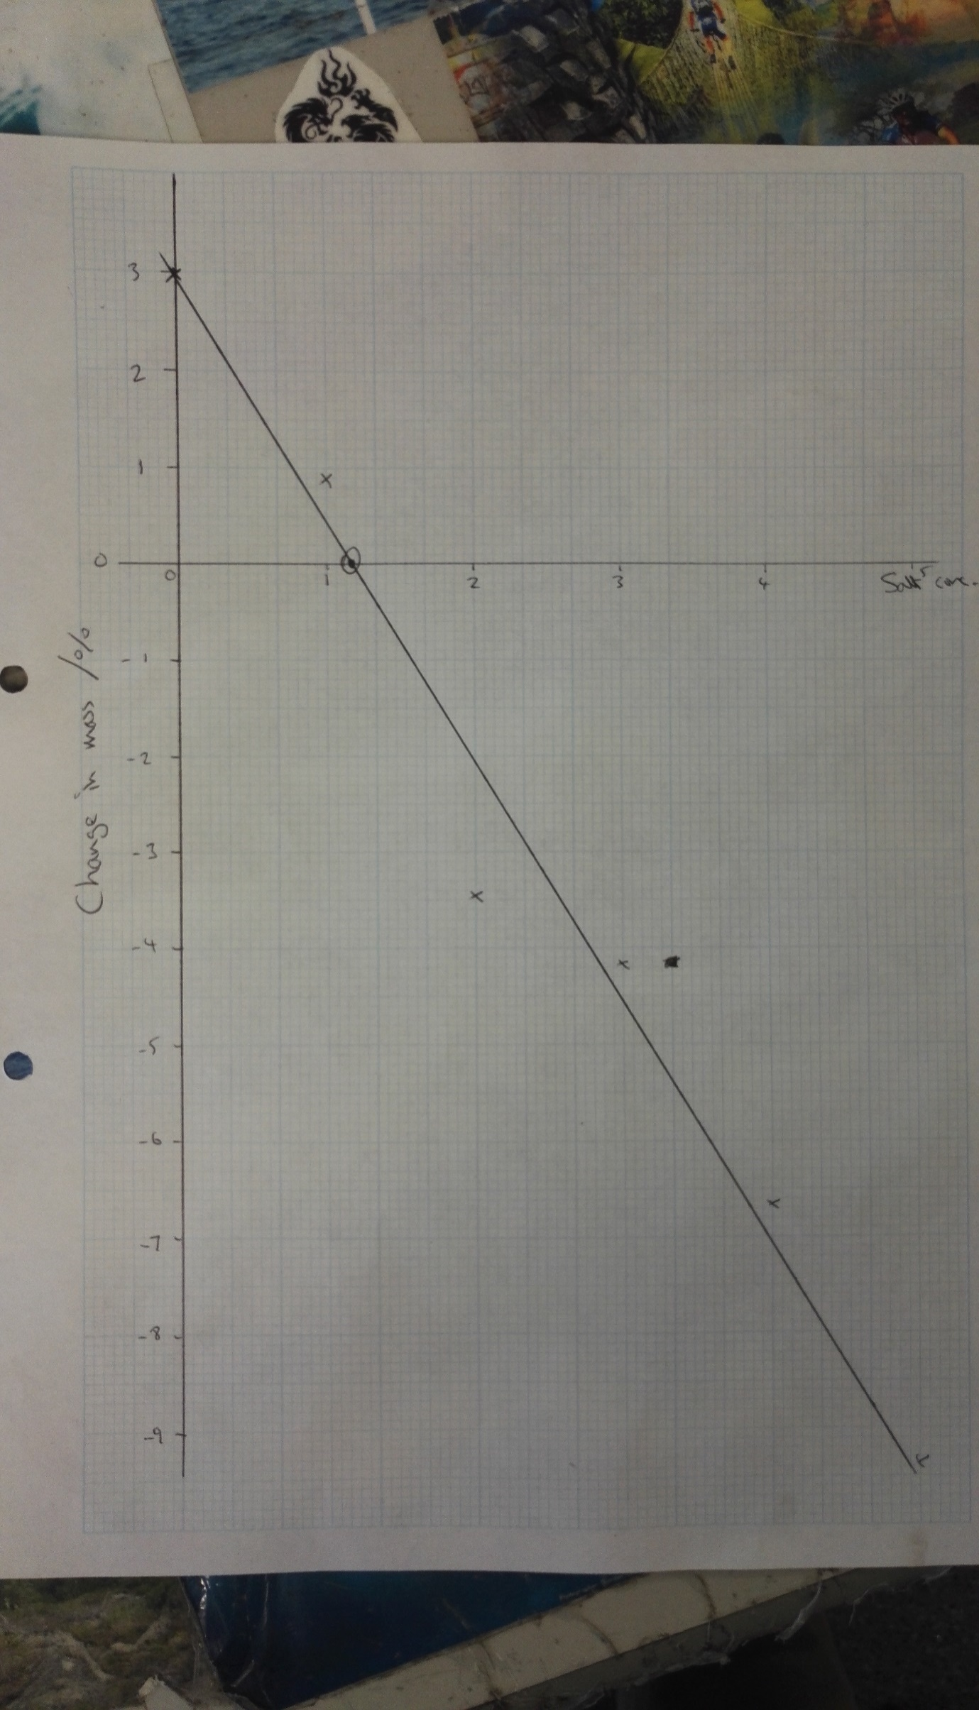

The movement of water into and out of plant cells

Plants cells loose and gain water by …………………… depending on the solutions surrounding them. If they are surrounded by a very dilute solution then water ………………… the cells, fills their vacuole and pushes the cell contents against the cell wall making it hard (……………………). The cell wall prevents the cell from bursting. If the solution surrounding the cell becomes more concentrated than inside the cell, then water ……………… by osmosis and the cell becomes floppy (………………………).

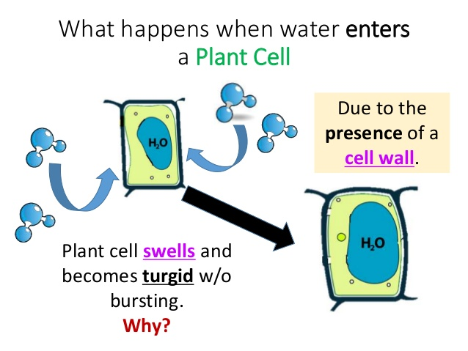

1. 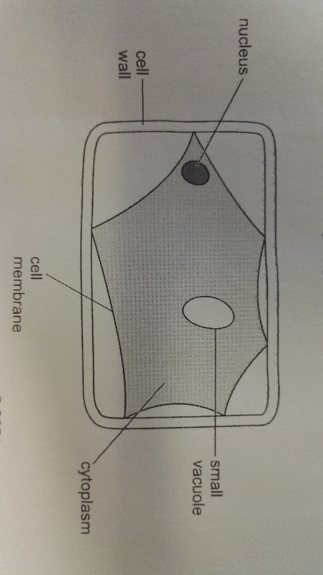The diagram below shows a plant cell as seen under a microscope. The cell had been left in strong sugar solution for 30 minutes.
2. What term describes the cell as it appears in the diagram?

…………………………………………………………. [1]

1. Redraw the cell, **to the same scale**, as it would appear after being left in water for 30 minutes.

Label the **cell wall, cell membrane** and **vacuole** on your drawing.

[4]

**Transpiration**

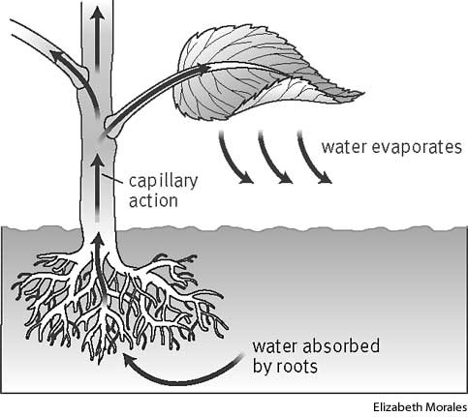Plants use water for transpiration, support, transport and photosynthesis.

Water enters plants through their root hair cells by osmosis and is pulled up through the stem because of osmosis.

Transpiration is the evaporation of water from leaf cells followed by diffusion through the stomata.

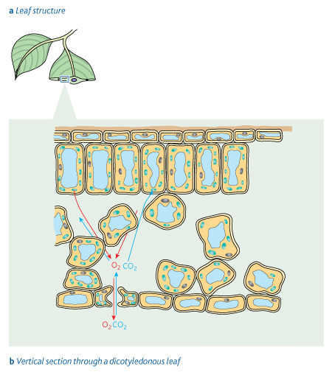

Factors affecting the rate of Transpiration

We can investigate the **rate of transpiration** using a potometer There are 2 types of potometer. A bubble potometer and the weighing method;

bubble

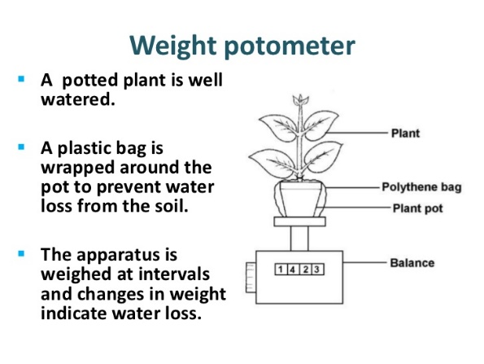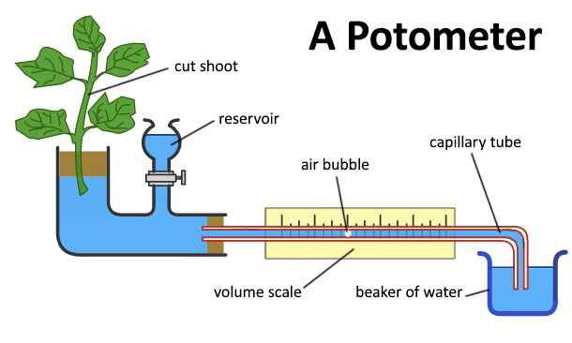

**Factors affecting transpiration**;

|  |  |  |
| --- | --- | --- |
| **Factor** | **How it affects the rate of transpiration** | **Explanation** |
| Wind speed | The faster the wind, the faster transpiration | Keeps concentration gradient high so more diffusion of water |
| Temperature | The warmer the air, the faster transpiration | Faster moving particles, so more diffusion of water. |
| Humidity | The wetter the air (higher humidity), the slower transpiration | Creates low concentration gradient so less diffusion of water |
| Surface area of leaf | The greater the s.a., the faster transpiration. | Small or less leaves have less stomatal pores. Less stoma, less diffusion of water. |

**Uses of Water;**

Plants need water for;

1. **Support** – having cells that are full of water keeps them turgid and keeps the whole plant upright.
2. **Transport** – moving water through Xylem also helps plants bring dissolved minerals such as nitrates, magnesium etc… to the leaves. Also, plants move dissolved sugars through their Phloem tissue.
3. **Transpiration**
4. **Photosynthesis** – water is a raw material for photosynthesis