Chemistry Unit C1: Structures, Trends, Chemical Reactions, Quantitative Chemistry and Analysis
C1.1 Atomic structure
Content - CCEA Double Award Chemistry 1 – Fort Hill Integrated College | Got it | Nearly | Haven’t a clue
C1.1 Atomic structure
Can you describe the structure of an atom as a central positively charged nucleus containing protons and neutrons (most of the mass) surrounded by orbiting electrons in shells;
Can you state the relative charges and approximate relative masses of protons, neutrons and electrons;
Can you define atomic number as the number of protons in an atom;
Can you define mass number as the total number of protons and neutrons in an atom;
Can you describe and explain that an atom as a whole has no electrical charge because the number of protons is equal to the number of electrons;
Can you calculate the number of protons, neutrons and electrons in an atom or an ion and deduce the charge on an ion or determine the number of subatomic particles given the charge.
Can you write and draw the electronic configuration (structure) of atoms and ions with atomic number 1–20;
Can you define isotopes as atoms of an element with the same atomic number but a different mass number, indicating a different number of neutrons;
Can you interpret data on the number of protons, neutrons and electrons to identify isotopes of an element;
Can you calculate the relative atomic mass of elements from the mass number and abundances of its isotopes;
Can you recall that a compound is two or more elements chemically combined.

Atoms, elements and compounds
All materials are made up of tiny particles called ______. All materials can be sorted out into 3 different groups depending on how their atoms are arranged;
      - ________________
      - ___________
      - ___________
Elements are made of only ____ type of atom.
Compounds consist of two or more different atoms ____________ ________ together.
Mixtures are made of different types of atom but these are _________ __________ and are not chemically bonded.

Iron, Fe | Water, H₂O | Air, N₂ + O₂

Sulphur, S | Carbon dioxide CO₂ | Sulphur, S and Iron, Fe

We use letters to stand for elements. We call these _______________. For example, Na stands for one atom of ______________ and O stands for one atom of ______________. The periodic table shows all of the elements. Each column contains elements with similar ______________. We call each column a _____________.
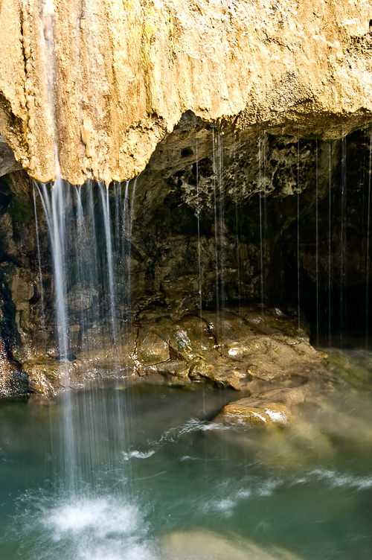
What’s in a compound?
When atoms of different elements join together we get a substance called a ____________. Most substances are compounds.
The __________ of a compound tells us;
- Which ____________ are in the compound,
- How _______ atoms of each element there are in the compound.

Name of compound | Formula | Atoms in the compound
Carbon Dioxide |  | 1 carbon atom  2 oxygen atoms
Water
Ammonia
Calcium oxide
Copper Sulphate
Calcium Hydroxide

e.g. Limestone is mainly - Calcium carbonate, CaCO₃

Symbol
Element
Number of atoms

Describing elements and compounds

Use the letters in the boxes below to answer the questions that follow.
A  all the atoms are the same | B | C  contains more than one kind  of atom joined together
D | E  smallest particle  of an element | F
G  small group of atoms  held together by bonds | H | I  examples are found in  the Periodic Table
1 Which box or boxes describe or show a pure element? ____________
2 Which box or boxes describe or show a pure compound? ___________
3 Which box or boxes describe or show a molecule? ________________
4 Which box shows molecules that contain three atoms? ____________
5 Which box shows a diagram of an element that is not made up of molecules? _____________________________________________
6 Oxygen gas has the formula O₂. Which box shows a diagram of molecules of oxygen gas? __________________________________

The drawings below show the particles of atoms and molecules in different substances.

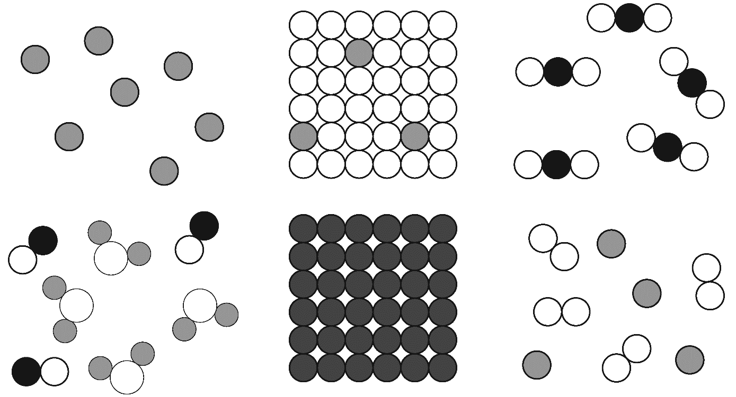  A | B | C
D | E | F

1 Which of the boxes shows a pure substance? __________________
2 Which of the boxes shows an impure substance? _______________
3 Which of the boxes shows a pure compound? __________________
4 Which of the boxes shows a pure element? ___________________
5 Match each of the descriptions below with the correct box:
a the atoms of solid pure gold (Au) _________________________
b the molecules of water (H₂O) and carbon monoxide (CO) mixed together __________________________________________________
c atoms of the element argon (Ar) as a gas ____________________
d a mixture of solid silver (Ag) with a few atoms of copper (Cu) _____
e pure carbon dioxide (CO₂) gas ____________________________
f a mixture of neon (Ne) and oxygen (O₂) gases. _______________

The air is a mixture made up of different elements and compounds. The main gases in air are given in the table below, along with the amount of each found in 100cm³ of dry air. Dry air has no water vapour in it.
Gases in the air

Name of gas | Approximate volume of each gas in 100cm³ of air
Nitrogen N₂ | 78
Oxygen O₂ | 21
Argon Ar | 1
carbon dioxide CO₂ | 0.03

- Why would it be so difficult to show the amount of carbon dioxide in the air on a graph? ……………………………………………………………………………………………………
- Which is the most abundant gas in air? ………………………………………….
- Which gas makes up about one-fifth of the air? …………………………………….
- Label each molecule below.
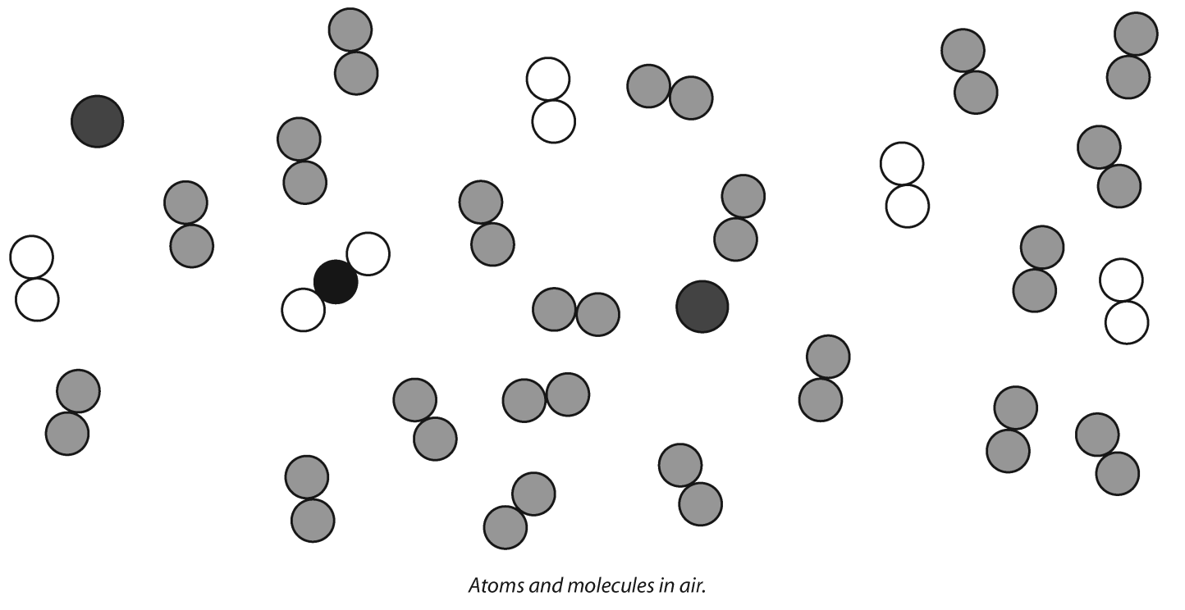

Atoms and molecules in air

1 Air is a mixture of different gases.
a Colour in the atoms. Use a different colour for each different type of atom.
b Fill in the missing parts of the table.

 | Name of gas | Atoms or molecules? | Element or compound?
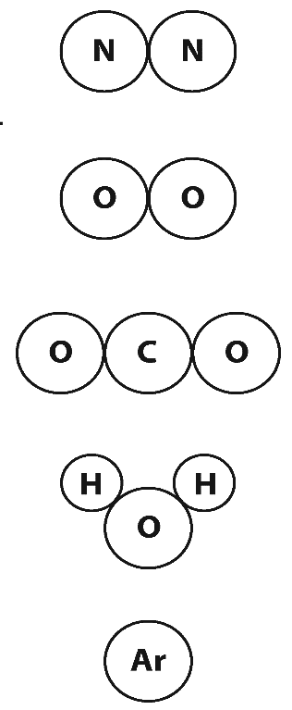 |  | molecules | element
 |  |  | compound
 | argon |  | element

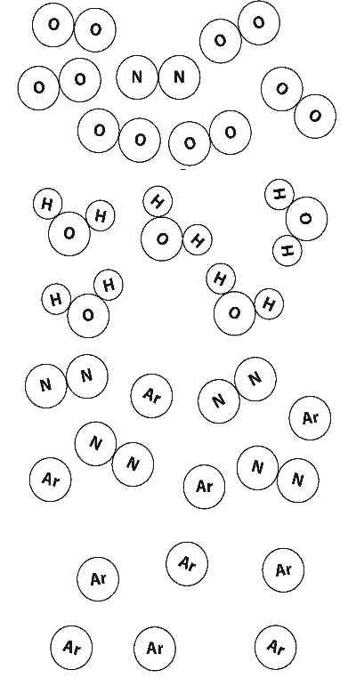
2
A

B

C

D

This question is about the particles in different substances.
a Match up the following descriptions with the correct drawing.
The first one has been done for you.
i pure argon
ii a mixture of nitrogen and argon
iii impure oxygen
iv pure water
b Colour in the atoms the same as for question 1.

Chemical Formula
A chemical formula tells you the number and type of each atom in a molecule of an element or a compound. Look at each formula on the left and draw a line to the model that best represents it.
Ammonia

NH₃
Hydrogen peroxide

H₂O₂
Hydrogen chloride

HCl
Hydrogen sulphide

H₂S

Oxygen

O₂

Methane

CH₄

[6]
C1.1 Atomic structure
Electronic structure and configuration of atoms 12/09/18
An atom can be described as a central positively charged nucleus containing protons and neutrons surrounded by orbiting electrons in shells. The first shell around the nucleus can hold up to 2 electrons. The 2nd can hold 8 and so can the 3rd (2,8,8,2).
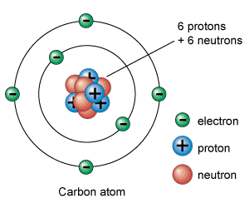

Name | Relative charge | Relative mass | Location
Proton | +1 Positive | 1 | Nucleus
Neutron | 0 Neutral | 1 | Nucleus
Electron | -1 Negative | 0 (1/2000) | Outside nucleus

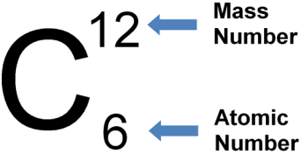
Atomic number and Mass number

The atomic (proton) number is defined as the number of protons in an atom.
As atoms are neutral (have no overall electrical charge), the number of protons is equal to the number of electrons.
The mass number is defined as the total number of protons plus neutrons in an atom (the heavy bits).
Using the Periodic table, we can calculate the number of Protons, Electrons and Neutrons for all atoms;
Number of neutrons = Mass number – Atomic number

