Chemistry Unit C1: Structures, Trends, Chemical Reactions, Quantitative Chemistry and Analysis
C1.9 Chemical Analysis
Content - CCEA Double Award Chemistry 1 – Fort Hill Integrated College | Got it | Nearly | Haven’t a clue
C1.9 Chemical Analysis
Assessing purity and separating mixtures
Can you recall that a pure substance is a single element or compound not mixed with any other substance;
Can you demonstrate recall that pure elements and compounds melt and boil at specific temperatures and melting point and boiling point can be used to distinguish pure substances from mixtures;
Can you demonstrate knowledge and understanding that a formulation is a mixture that has been designed as a useful product and is formed by mixing together several different substances in carefully measured quantities to ensure the product has the required properties, for example alloys, medicines and fertilisers;
Can you identify and define the terms soluble, insoluble, solute, solvent, solution, residue, filtrate, distillate, miscible, immiscible, evaporation and condensation;
investigate practically how mixtures can be separated using filtration, crystallisation, paper chromatography, simple distillation or fractional distillation (including using fractional distillation in the laboratory to separate miscible liquids, for example ethanol and water);
Can you describe paper chromatography as the separation of mixtures of soluble substances by running a solvent (mobile phase) through the mixture on the paper (stationary phase), which causes the substances to move at different rates over the paper; and
Can you interpret a paper chromatogram including calculating Rf values.
Can you analyse given data on mixtures to make judgements on the most effective methods of separation and plan experiments to carry out this separation;
Can you describe how to use anhydrous copper(II) sulfate to test for water;
Tests for ions
Can you describe how to carry out a flame test using nichrome wire and concentrated hydrochloric acid to identify metal ions;
Can you recall the flame colours of different metal ions:
- lithium (crimson);
- sodium (yellow/orange);
- potassium (lilac);
- calcium (brick red); and
- copper(II) (blue–green/green–blue); and
Can you describe how to identify the ions in an ionic compound using flame tests
(Prescribed Practical C2).

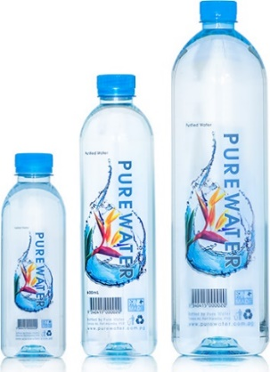
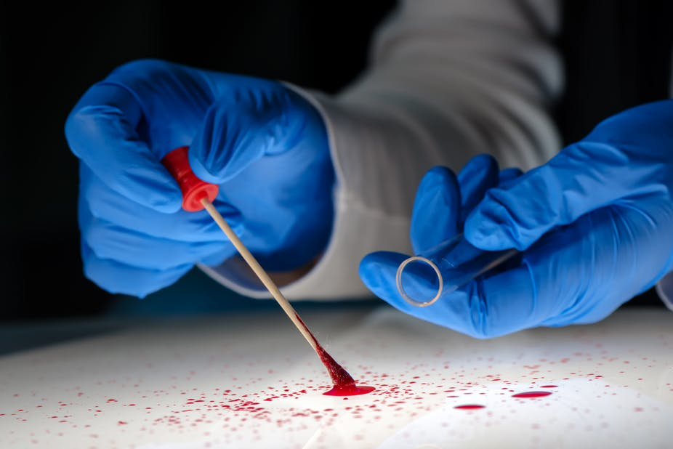
Assessing purity and separating mixtures
Chemical analysis is extremely important. It is used in forensics, the food industry, Water Board to identify and test the purity of different substances.

Pure substances
In chemistry a pure substance is a single element or compound not mixed with any other substance.
Pure substance | Mixture
(only the element carbon) | (O₂, N₂, CO₂, + trace gases)
(only H₂O) | (water + dissolved salts)
(only NaCl) | (water, lactose, fat + minerals)

Diamond | Water | Table salt | Air | Mineral water | milk

Melting and boiling point of pure substances and mixtures
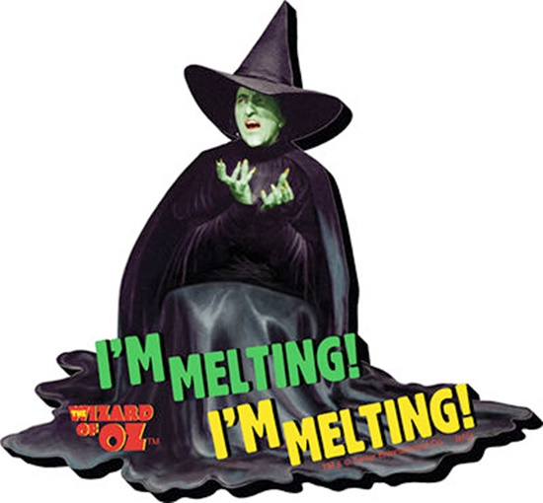
Melting point is the temperature at which a solid changes into a liquid.
Boiling point is the temperature at which a liquid changes into a gas.
Pure elements and compounds melt and boil at specific temperatures. Melting point and boiling point can be used to distinguish pure substances from mixtures. These are physical tests, not chemical tests.
e.g. water - boiling point 100ºC; melting point 0 ºC
sulphur - boiling point 444ºC; melting point 115 ºC
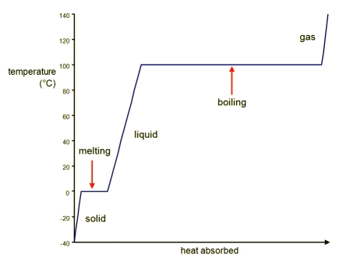
Impure substances do not have sharp melting or boiling points, but melt/boil over a range of temperatures. The presence of an impurity usually lowers the melting point of a solid or raises the boiling point of a liquid.

Formulations
A formulation is a mixture that has been designed as a useful product and is formed by mixing together several different substances in carefully measured quantities to ensure the product has the required properties. E.g. tomato ketchup, alloys, medicines and fertilisers.
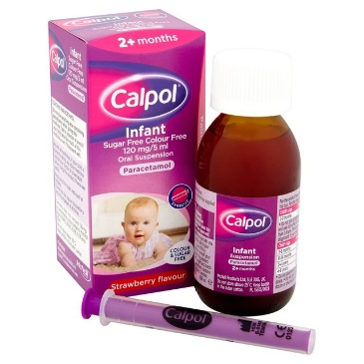
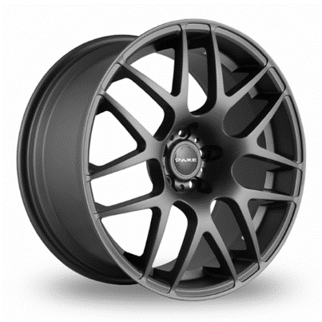
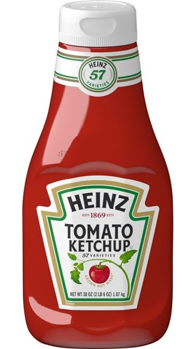

- The table shows the melting and boiling points of some metallic elements and alloys named by the letters A-C.
 | Melting point / ºC | Boiling point / ºC | Element or Alloy?
A | -34 | 356
B | 420 | 913
C | 1425 - 1540 | 2530 - 2545

- In what state is substance A at room temperature and pressure? …………
- In what state is substance B at room temperature and pressure? …………
- In what state is substance C at room temperature and pressure? …………
- What is an alloy? ……………………………………………………………………………………………………………………
- Classify the substances in the table as elements or alloys. Explain your answer.
………………………………………………………………………………………………………………………

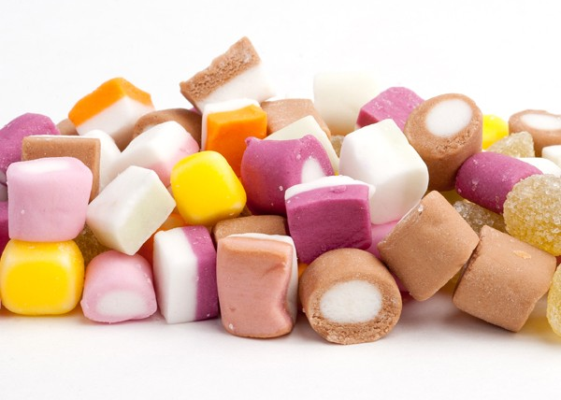
Separating mixtures
A mixture is defined as two or more substances mixed together. The substances in a mixture are easy to separate as they are not chemically bonded together.
Key terms
Term | Definition
soluble | A substance that will dissolve in a solvent
insoluble | A substance that will not dissolve in a solvent
solute | The substance that dissolves in a solvent
solvent | The liquid in which a solute dissolves
solution | A solute dissolved in a solvent
residue | The solid that remains on the filter paper after filtration
filtrate | The liquid which passes through the filter paper during filtration
distillate | The liquid that is cooled from the vapour and collected during distillation
miscible | Liquids that mix together e.g. alcohol and water
immiscible | Liquids which do not mix together but form two distinct layers e.g. oil and water
evaporation | The change of state from liquid to gas when heated
condensation | The change of state from gas to liquid when cooled

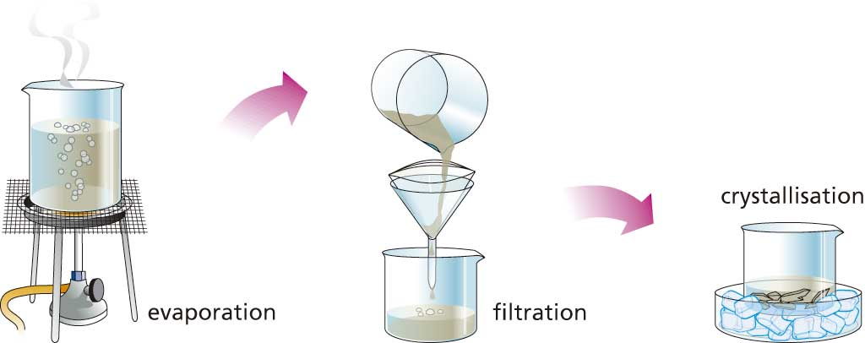
Separating techniques
The method used to separate a mixture depends on the physical properties of the components of the mixture.

- Filtration – used to separate an insoluble solid from a liquid e.g. sand and water
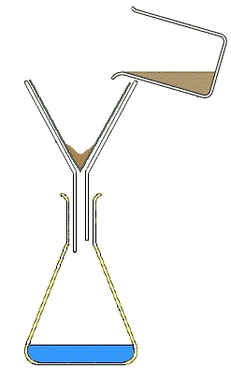

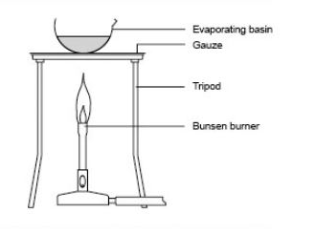
- Evaporation – to separate a dissolved solid from a solvent e.g. salt from a salt solution.

  - Crystallisation (another method of separating a dissolved solid from a solvent)
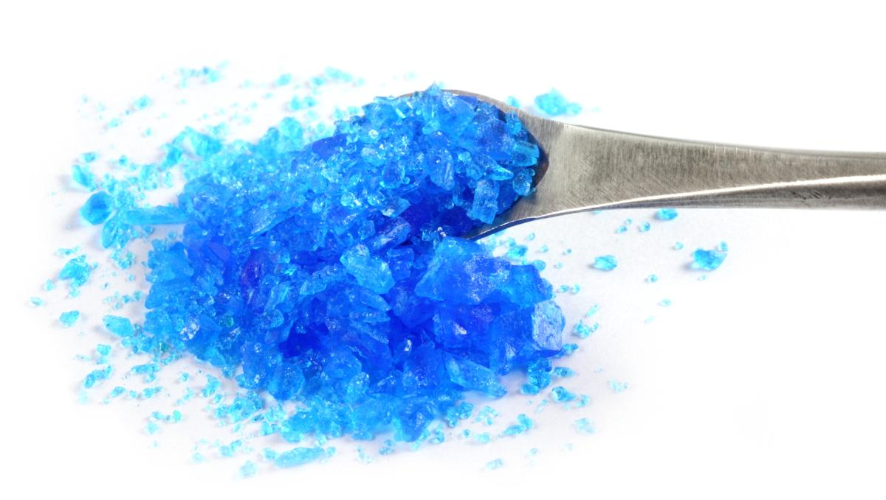
A solution is heated to boil off some solvent. This creates a saturated solution – one in which no more solid can dissolve at that temperature. The saturated solution then cools. The solute becomes less soluble and so cannot remain dissolved and crystallises out of solution.

- Simple distillation – used to separate a solvent from a solution
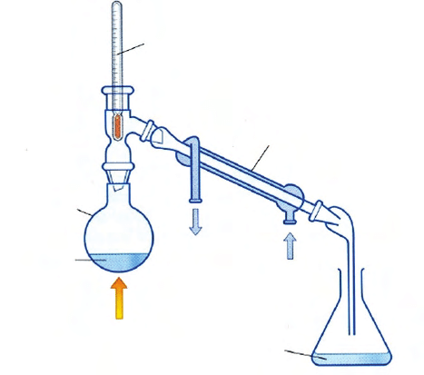
Distillation is evaporation followed condensation (anti-bumping granules are added to the mixture in the flask to promote smooth boiling).

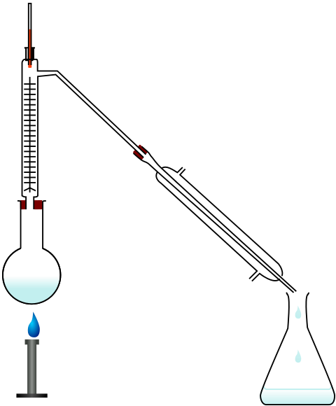
- Fractional distillation – used to separate miscible liquids which have different boiling points.
The long fractionating column provides better separation of liquids as any evaporated liquids below their boiling point condense in the column and fall back down into the flask. This means the fractions are pure.

Quick questions
- A mixture of insoluble copper (II) carbonate and water was separated by filtration.
  - Name the filtrate: ……………………………………………………………
  - Name the residue: ……………………………………………………………
- Pure water can be obtained by distillation of copper (II) sulfate solution.
  - Name the solute in copper (II) sulfate solution.
………………………………………………………………………………………………
  - Name the change of state which occurs in the distillation flask.
………………………………………………………………………………………………
  - What is the distillate?
………………………………………………………………………………………………
  - What is added to the distillation flask to ensure smooth boiling? …………………………………………………………

- Paper chromatography – used to separate mixtures of soluble substances in a solution e.g. inks, dyes, food colouring.
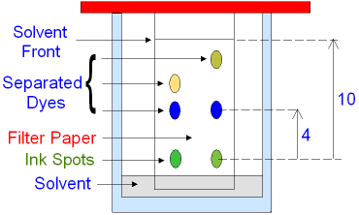

Method
- Draw a pencil line 1-2cm from the bottom of chromatography paper.
- Place a concentrated spot of substance on the pencil line.
- Place the paper in a beaker with the solvent at the bottom.
- Leave the solvent to travel up the paper.
- When the solvent is near the top, take the paper out of the solvent and mark the level that it reached – the solvent front (the furthest distance travelled by the solvent)
- Leave the paper to dry. The mixture should have separated into different components, seen as spots on the paper.
In paper chromatography, the stationary phase is the paper and the mobile phase is the solvent.
Each substance in the mixture moves at a different rate up the paper (depending on their relative attraction to the paper and the solvent).

R_{f} values
The separated components of the mixtures can be identified by calculating the R_{f} value using the equation:
R_{f} | = | distance moved by substance
 |  | distance moved by solvent
The R_{f} value of a particular substance in the same solvent is always the same.
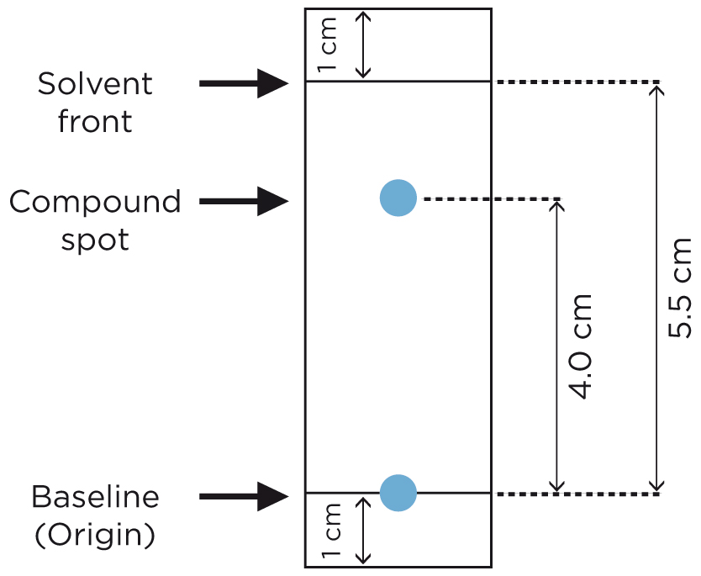

Try Q5 C1 H Feb 2019

Chemical Test for water
Water turns white anhydrous copper(II) sulphate blue.
Anhydrous copper (II) sulfate + water hydrated copper (II) sulfate
CuSO₄ + 5H₂O CuSO₄.5H₂O
Prescribed Practical C2
Cation tests – cations can be identified by carrying out a flame test;
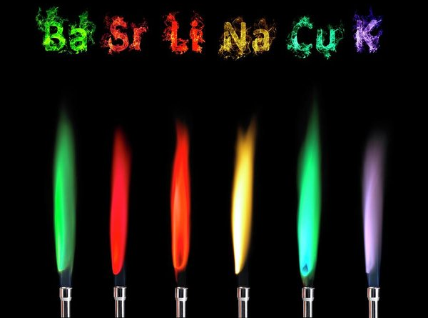
Method
- Dip a loop of nichrome wire into concentrated hydrochloric acid and then into the salt to be tested.
- Place the loop into a blue Bunsen burner flame and record the first colour observed
Metal ion present | Flame colour
Lithium (Li⁺) | Crimson
Sodium (Na⁺) | Yellow/orange
Potassium (K⁺) | Lilac
Calcium (Ca²⁺) | Brick-red
Copper (Cu²⁺) | Blue-green/green-blue
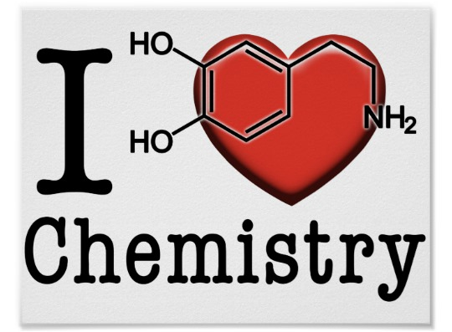

Calcium burns red and  Copper blue-green,  You are the sweetest  That I’ve ever seen. | Lithium is crimson,  Sodium is yella,  You should love me  I’m a hell of a fella. | Potassium is lilac  I’m delighted to say  If you don’t love me  I’ll try being single.
DAS textbook P234/5 – Practice questions

