**Unit 2: Body Systems, Genetics, Microorganisms and Health**

2.4 Genome, chromosomes, DNA and genetics

|  |  |  |  |
| --- | --- | --- | --- |
| **Content - CCEA Double Award Biology 2 – Fort Hill Integrated College** | Got it | Nearly | Haven’t a clue |
| **2.4 Genome, chromosomes, DNA and genetics** | | | |
| Can you describe the genome as the entire genetic material of an organism; |  |  |  |
| **Chromosomes** |  |  |  |
| Can you identify and describe chromosomes as genetic structures occurring in functional pairs in the nucleus of cells, except gametes and bacteria? |  |  |  |
| **Genes and alleles** |  |  |  |
| Can you identify and describe genes and alleles as sections of chromosomes made up of short lengths of DNA that operate as functional units to control characteristics and demonstrate understanding that alleles are different forms of the same gene; |  |  |  |
| **DNA structure** |  |  |  |
| Can you demonstrate knowledge and understanding of the structure of DNA, including:   * a phosphate and sugar (deoxyribose) backbone with interlinking bases to form a double helix; * base pairing rules and the unique nature of an individual’s DNA; and * **the link between the DNA code and the build-up of amino acids in the correct sequence to form protein: the base triplet hypothesis (transcription and translation not required);** and |  |  |  |
| **Cell division** |  |  |  |
| Can you demonstrate knowledge and understanding of mitosis as part of the cell cycle, limited to cell growth and cell division, which allows organisms to:   * grow; * replace worn out cells; and * repair damaged tissue. |  |  |  |
| **Mitosis** |  |  |  |
| Can you outline mitosis as the exact duplication of chromosomes producing daughter cells that are genetically identical to parent cells and clones (names of phases and details of DNA replication not required); |  |  |  |
| **Meiosis** |  |  |  |
| Can you demonstrate knowledge and understanding of meiosis as reduction division (one cell producing four genetically different, haploid daughter cells) **and as a** **process that, through independent assortment, reassorts the chromosomes to provide variation (crossing over and the stages of meiosis are not required)**; |  |  |  |
| **Genetic diagrams and terminology** |  |  |  |
| Can you demonstrate knowledge and understanding of and interpret genetic diagrams consisting of a single characteristic controlled by a single gene with two alleles (monohybrid cross) in plants, animals and humans, including:   * dominant and recessive alleles; * genotype, phenotype, gamete and offspring ratios, percentages and probabilities; * homozygous and heterozygous genotypes; * Punnett squares to determine genotype frequencies; * **test (back) crosses to determine an unknown genotype; and** * **pedigree diagrams;** |  |  |  |
| **The X and Y chromosomes** |  |  |  |
| Can you demonstrate knowledge and understanding of how sex is determined in humans; and |  |  |  |
| **Genetic conditions** |  |  |  |
| Can you demonstrate knowledge and understanding of and explain the inheritance of these genetic conditions:   * **haemophilia**; * cystic fibrosis; * Huntington’s disease; and * Down’s syndrome. |  |  |  |
| **Genetic screening** |  |  |  |
| Have you explored the increasing understanding of the human genome and evaluate associated ethical issues of genetic screening, including:   * who decides who will be tested; * benefits and risks of amniocentesis compared to blood tests; * the dilemma for carriers of genetic conditions after a test that diagnoses abnormalities; and * making genetic information available to wider society, for example insurance companies; and |  |  |  |
| **Genetic engineering** |  |  |  |
| Can you demonstrate knowledge and understanding of genetic engineering as a process that modifies the genome of an organism to introduce desirable characteristics, **including:**   * **the basic techniques used to produce human insulin for treatment of diabetes (transfer of a human insulin gene into a plasmid of a bacterial cell to form a genetically modified bacterium that can then be cultured in a fermenter to produce human insulin);** * **using restriction enzymes to produce ‘sticky ends’;** * **the need for down streaming (extraction, purification and packaging) to produce a pure form of insulin that can be used to treat diabetes; and** * **the advantages of producing human insulin and other products by this method.** |  |  |  |

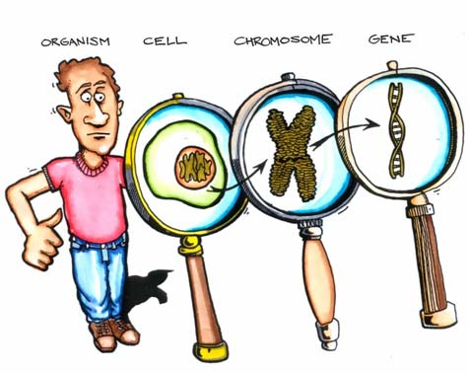**Chromosomes, Genes and DNA**

The entire genetic material of an organism is described as its genome.

Chromosomes are genetic structures made of the chemical DNA. They are stored in the nucleus of each cell and occur as functional pairs (except in gametes (sex cells) and bacteria).

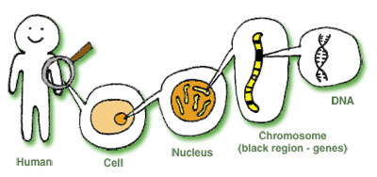Each normal human nucleus contains 46 chromosomes (23 pairs). Genes and alleles (different forms of the same gene) are sections of chromosomes (short lengths of DNA) that operate as functional units to control characteristics.

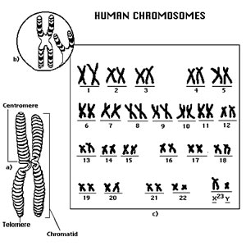

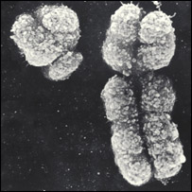

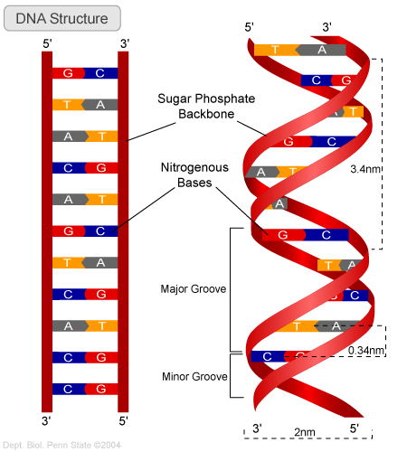

Phosphate sugar backbone

Base pairs

**DNA Structure**

The shape of DNA is described as a ……………… ……………. It is made of a phosphate and sugar (deoxyribose) backbone with interlinking bases to form a double helix. These 4 base pairs can only join in certain ways – A-T & G-C which allows DNA to replicate itself.

DNA cocktail <https://www.youtube.com/watch?v=mqk5hEJxwhk>

|  |
| --- |
| Do you understand the structure of DNA as;   * **the link between the DNA code and the build-up of amino acids in the correct sequence to form protein: the base triplet hypothesis (transcription and translation not required)** |

**How does DNA work? (Higher tier)**

The DNA works by providing a code to allow the cell to make the p……………… that it needs. The DNA determines which proteins, and in particular which e…………………, are made. Enzymes are extremely important proteins that control the cell’s reactions. Therefore, by controlling the enzymes, the DNA controls the development of the cell and in turn the entire organism.

The bases along one side (strand) of the DNA molecule – the coding strand – form the genetic code. Each sequence of ………… bases (a triplet) along this coding strand codes for a particular …………… …………… - the building blocks of proteins. The sequence of three bases that codes for an amino acid is called a **base triplet**. As a protein consists of many amino acids linked together it is important that the correct base triplets are arranged in the correct sequence along the coding strand.

The diagram shows how base triplets code for particular amino acids. The first and forth base triplets have the same code and this means that amino acid 1 and amino acid 4 are also the same. The model only shows a small section of a gene and a small section of the protein that it produces codes for.

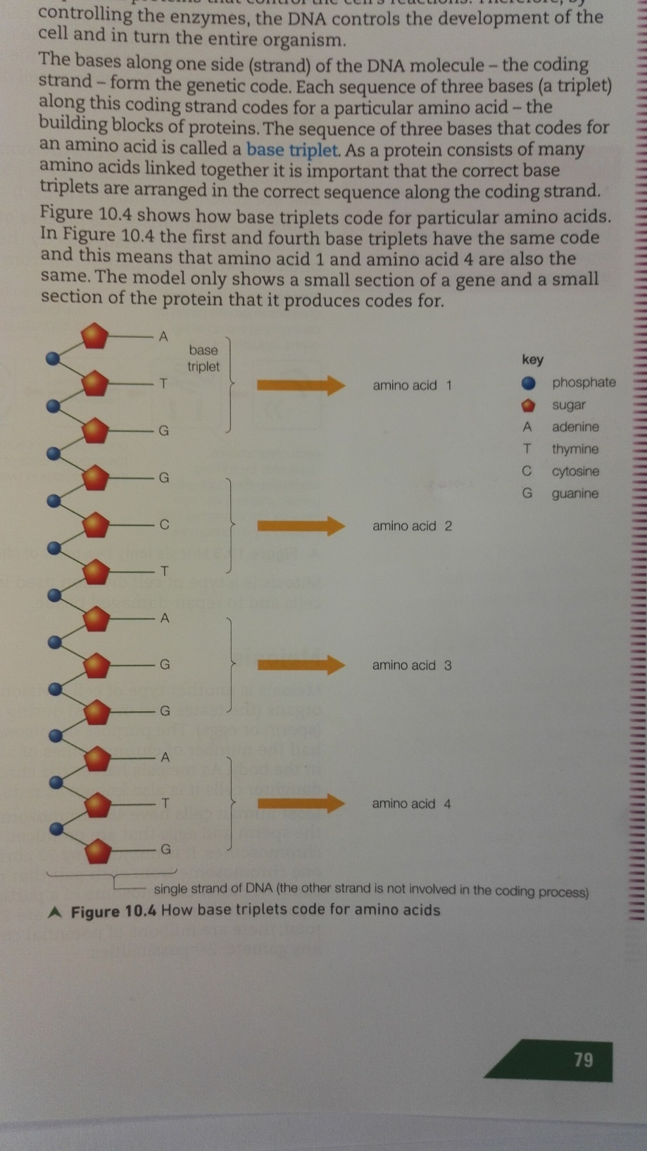

[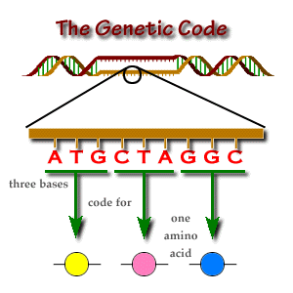](http://www.google.co.uk/url?sa=i&rct=j&q=&esrc=s&source=images&cd=&cad=rja&uact=8&ved=2ahUKEwi57MCRrNTfAhWBqHEKHXl1AzcQjRx6BAgBEAU&url=http://www.brooklyn.cuny.edu/bc/ahp/BioInfo/GP/GeneticCode.html&psig=AOvVaw0FKx05DU0ML31qCxG1-m-q&ust=1546698782357059)

**The X and Y Chromosomes**

In humans, sex is determined by which combination of chromosomes are present. Males are ………. and females are ……….

[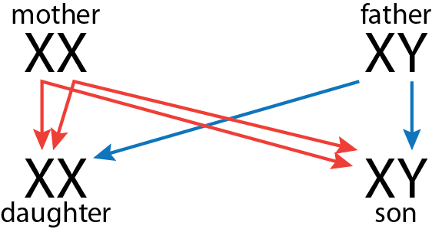](https://www.google.co.uk/url?sa=i&rct=j&q=&esrc=s&source=images&cd=&cad=rja&uact=8&ved=0ahUKEwiGp5PJrZHZAhVjIcAKHf0EANgQjRwIBw&url=https://www.calpoly.edu/~bio/bio161/html/week9.html&psig=AOvVaw2_hkLiOKfeE0tmXY-QfkOF&ust=1518008788664366)



|  |  |  |  |
| --- | --- | --- | --- |
|  |  | **Sperm** | |
|  |  | X | Y |
| **Egg** (Ovum) | X |  |  |
| X |  |  |

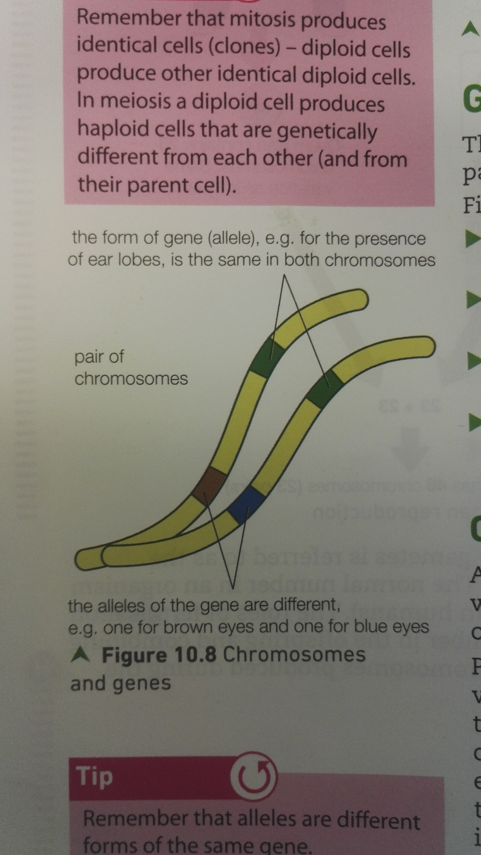**Genetics**

The science of genetics explains how characteristics pass from parents to offspring.

* ……………………………… are arranged in pairs – humans have …… pairs, which is …… chromosomes in total
* ……………… are sections of chromosomes that carry the code for particular characteristics such as eye colour
* Similar genes occupy the same position on both chromosomes in a pair
* Genes exist in different forms, called ………………, and the alleles may be …………zygous (the same), or …………zygous (different) on the two chromosomes of a pair
* Phenotype – the physical appearance caused by the alleles
* Genotype – the combination of Genes (alleles) present
* Dominant allele – will be expressed in the Phenotype, even if the other allele is recessive
* Recessive allele – will only be expressed in the Phenotype of both alleles are the same
* If both alleles are the …………… we say the genotype is …………zygous
* If both alleles are different we describe the genotype as ……………zygous;

**Genetic crosses (Textbook P82-86)**

[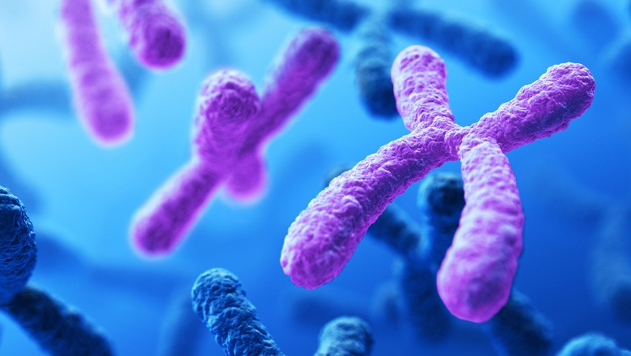](https://www.google.co.uk/url?sa=i&rct=j&q=&esrc=s&source=images&cd=&cad=rja&uact=8&ved=2ahUKEwidjN6wqqTgAhWCsXEKHYiBCsIQjRx6BAgBEAU&url=https://biology.mit.edu/faculty-and-research/areas-of-research/genetics/&psig=AOvVaw2h0lEjjAbcSoyb4BFasB_q&ust=1549447035258712)A monohybrid cross is a cross between 2 individuals where the genetics of one characteristics (e.g. height in peas or eye colour in humans) is considered.

Pea plants occur in their normal tall forms or in a much shorter variety. One genetic cross that can be carried out is a cross between tall and short plants. Before carrying out this cross, the tall plants can be allowed to breed with each other for a period of time to ensure they always produce tall plants. The same can be done with the short plants by allowing only short plants to breed together until it is certain they could only produce short offspring. The parent plants to be used are then referred to as pure breeding.

[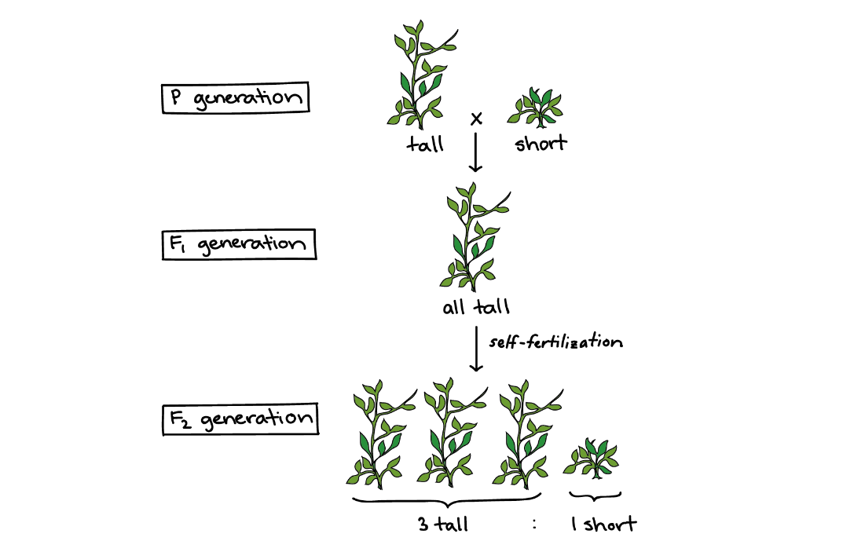](https://www.google.co.uk/url?sa=i&rct=j&q=&esrc=s&source=images&cd=&cad=rja&uact=8&ved=2ahUKEwihpOjuqaTgAhV9XhUIHWDJBaEQjRx6BAgBEAU&url=https://www.khanacademy.org/science/high-school-biology/hs-classical-genetics/modal/a/mendel-and-his-peas&psig=AOvVaw1ycBgfyanuxUtY6VP5ZJn-&ust=1549446952595547)When pure breeding tall plants are crossed with pure breeding short plants (the parental generation), all the plants in the first, or F1 generation, (the offspring) are tall. However, if these F1 plants, their offspring (the second or F2 generation) are a mixture of tall and short plants in the ratio of 75% tall to 25% small.

**Explanation of this monohybrid cross**

The results of this genetic cross can be explained by understanding the gene involved – in this case, the gene that determines height. There are two forms of the height gene – a tall and a short gene. The different forms of a gene are called alleles. In the example of the height in peas, there is an allele for tallness and an allele for shortness. In genetic crosses, alleles are represented by a single letter, e.g. T for tall and t for short.

As the parental plants were pure breeding, the tall plants only carried the tall alleles and short plants only carried the short alleles. These plants containing only one type of allele are homozygous (TT or tt). When both types of allele are present, the individual is heterozygous (Tt).

The paired symbols (TT, Tt or tt) used in genetics are referred to as the **genotype** and the outward appearance (tall or short) is the **phenotype**.

When gametes are produced, only one allele (from each gene) from each parent passes on to the offspring. This is fully explained by our understanding of meiosis, as we know that only one chromosome, and therefore one allele, of each pair can pass into a gamete.

The F1 plants in our cross must have received one T allele from their tall parent and one t allele from the short parent. The F1 plants were therefore Tt (heterozygous). Although all these plants contained both the T and the t allele, they were tall. This can be explained by considering the T allele as being **dominant** over the **recessive** t allele. The recessive condition will only be expressed, or visible, in the phenotype when only recessive alleles are present in the genotype (tt).

The diagram shows that when the F1 plants were interbred a ratio of 3:1 (tall: short) was produced. This ratio was achieved because the two alleles (T and t) of one parent were produced in equal numbers during meiosis and they had an equal chance of combining with the T or the t allele produced by the other parent during fertilisation.



When completing genetic diagrams, it is helpful to use a small grid called a **Punnett square**. this is a way of setting out a genetic cross in table format. In this example, using height in peas as before, a heterozygous pea (Tt) is crossed with a homozygous recessive pea (tt).

|  |  |  |  |  |  |  |
| --- | --- | --- | --- | --- | --- | --- |
| Parent phenotype | |  | tall | x | short |  |
|  |  |  |  |  |  |  |
| Parent genotype | |  | Tt | x | tt |  |
|  |  |  |  |  |  |  |
| genotype | | T or | t |  | t or | t |
|  |  |  |  |  |  |  |
|  |  |  | t | t |  |  |
|  |  | T |  |  |  |  |
|  |  | t |  |  |  |  |
|  |  |  |  |  |  |  |
|  | genotypes |  | Tt | Tt | tt | tt |
| offspring |  |  | tall | tall | short | short |
|  | phenotypes |  |  |  |  |  |
| ratio |  |  |  | 1:1 | |  |

Complete the Punnett squares below to show examples of monohybrid crosses that can occur in humans. In these examples of eye colour, brown eye colour (B) is dominant to blue eye colour (b). Give the possible genotypes and ratios of phenotypes. In each case, give the phenotype of each parent

|  |  |  |  |  |
| --- | --- | --- | --- | --- |
| Mother’s eye colour = |  | Mother’s gametes | | |
| Father’s eye colour = | Father’s gametes |  | **B** | **B** |
| Possible genotypes of offspring | **b** |  |  |
| Likely ratio of phenotypes | **b** |  |  |

|  |  |  |  |  |
| --- | --- | --- | --- | --- |
| Mother’s eye colour = |  | Mother’s gametes | | |
| Father’s eye colour = | Father’s gametes |  | **B** | **b** |
| Possible genotypes of offspring | **b** |  |  |
| Likely ratio of phenotypes | **b** |  |  |

|  |  |  |  |  |
| --- | --- | --- | --- | --- |
| Mother’s eye colour = |  | Mother’s gametes | | |
| Father’s eye colour = | Father’s gametes |  | **B** | **b** |
| Possible genotypes of offspring | **B** |  |  |
| Likely ratio of phenotypes | **b** |  |  |

N.B.

* ratios will only be accurate when large numbers of offspring are produced. this is because it is totally random which gametes and therefore alleles, fuse during fertilisation
* It is common practise to use the same letter for both the dominant and recessive alleles, with the dominant allele being the capital and the recessive allele written in lower case
* if a 3:1 ratio is present in the offspring of a particular cross, both of the parents involved will be heterozygous for the characteristic being considered
* If a 1:1 ratio is produced in a cross, one parent will be heterozygous and the other homozygous recessive

[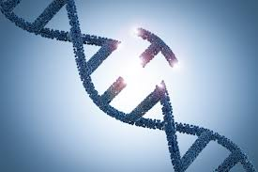](https://www.google.co.uk/url?sa=i&rct=j&q=&esrc=s&source=images&cd=&cad=rja&uact=8&ved=2ahUKEwjJ6IPI4aziAhWGRxUIHYFPDvwQjRx6BAgBEAU&url=https://www.agweb.com/mobile/article/gene-editing-finds-its-way-to-the-farm/&psig=AOvVaw1onYiudP4SkF-ITzizL3mk&ust=1558532804293080)**Genetic conditions**

Genetic conditions are caused by a fault with genes or chromosomes> some genetic conditions are inherited – passed from parent to child. **Haemophilia**, cystic fibrosis, Huntington’s disease and Down’s syndrome are all genetic conditions, but each is caused by a different type of genetic problem.

|  |  |  |
| --- | --- | --- |
| Condition | Problem | Cause |
| **Haemophilia** | Blood-clotting failure can result in excessive bleeding even from very small wounds or bruising | Sex-linked inherited condition caused by a recessive allele on the X chromosome |
| cystic fibrosis | Frequent and serious lung infections and problems with food digestion | Caused by a recessive allele – individuals with the disease must be homozygous recessive |
| Huntington’s disease | Affects nerve cells in the brain leading to brain damage, which usually becomes apparent in middle age. Fatal with no cure | Caused by presence of a dominant allele |
| Down’s syndrome | Reduced muscle tone and reduced cognitive development | Caused by the presence of an extra chromosome (occasionally gametes are formed with 24 chromosomes (instead of 23). |

[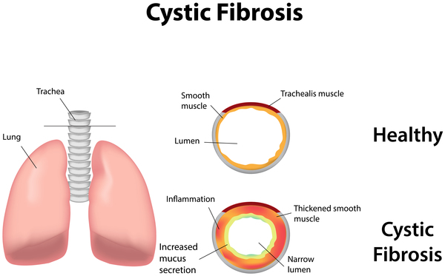](https://www.google.co.uk/url?sa=i&rct=j&q=&esrc=s&source=images&cd=&ved=2ahUKEwjH6Pv746ziAhVmRRUIHVp4AdwQjRx6BAgBEAU&url=https://ghr.nlm.nih.gov/condition/cystic-fibrosis&psig=AOvVaw1BKZerxr0wFDpWSHiGu9MP&ust=1558533513688341)[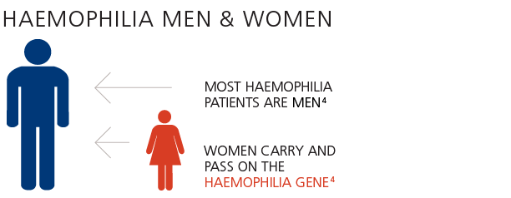](https://www.google.co.uk/url?sa=i&rct=j&q=&esrc=s&source=images&cd=&ved=&url=https://www.novonordisk.com/patients/haemostasis-management/understanding-haemophilia.html&psig=AOvVaw2tiIpOW-UuzDZdg1b3Su3L&ust=1558533186548850)

[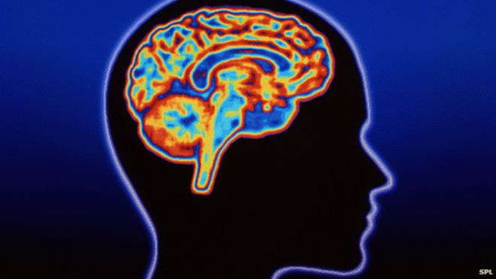](https://www.google.co.uk/url?sa=i&rct=j&q=&esrc=s&source=images&cd=&cad=rja&uact=8&ved=2ahUKEwiDgrrN5KziAhVyRBUIHYDmCAYQjRx6BAgBEAU&url=https://www.bbc.co.uk/news/uk-scotland-32800666&psig=AOvVaw37zb_PCGJKiY4qvX_CW2X-&ust=1558533670166851)

[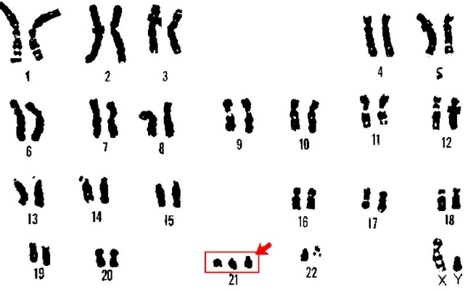](https://www.google.co.uk/url?sa=i&rct=j&q=&esrc=s&source=images&cd=&ved=2ahUKEwiGmPWu6qziAhUTSxUIHQBtBNAQjRx6BAgBEAU&url=https://www.nationalgeographic.com/science/phenomena/2013/07/17/how-to-shut-down-the-extra-chromosome-in-downs-syndrome/&psig=AOvVaw0MyJsMhOoUkw9Jw-aAcpvC&ust=1558535188705725)

[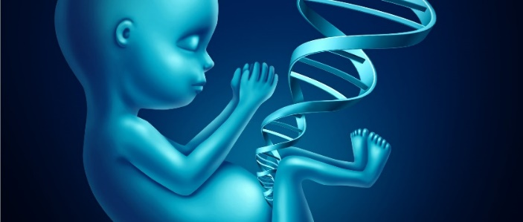](https://www.google.co.uk/url?sa=i&rct=j&q=&esrc=s&source=images&cd=&ved=2ahUKEwj2k7DF8KziAhVPUBUIHVoTBz0QjRx6BAgBEAU&url=https://www.geneticsdigest.com/how-beneficial-is-genetic-testing-before-pregnancy/&psig=AOvVaw2XiZvT3MGmx5_i3GuhnNvD&ust=1558536866069188)**Genetic screening**

**Genetic screening** can be used to reduce the incidences of genetic disorders or help prepare people for a child with a disorder.

[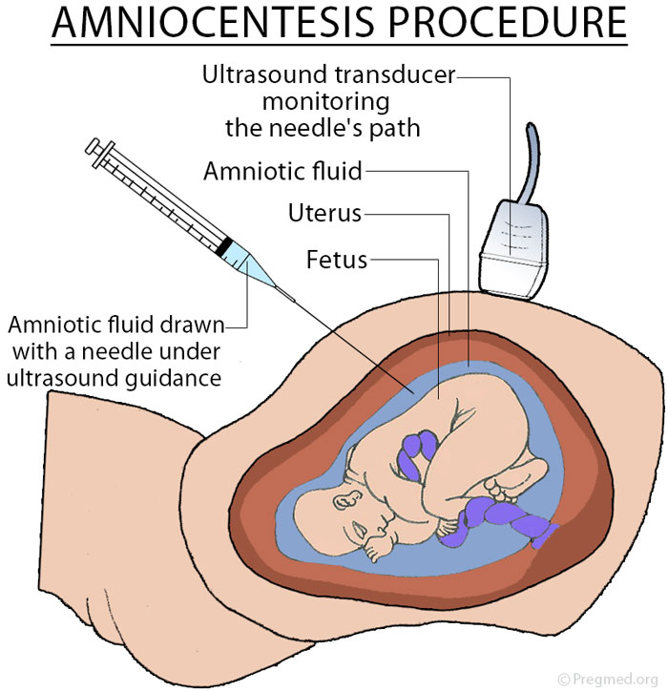](https://www.google.co.uk/url?sa=i&rct=j&q=&esrc=s&source=images&cd=&ved=2ahUKEwjZ9u3q8KziAhWTqHEKHW4-CCgQjRx6BAgBEAU&url=https://www.pregmed.org/amniocentesis.htm&psig=AOvVaw2jJxh1tkXFefkyjiZFlKQT&ust=1558536955377836)**Amniocentesis** involves inserting a needle into the **amniotic fluid** and examining the foetal cells in the fluid for the presence of genetic abnormalities.

Amniocentesis can help identify a range of conditions including Down’s Syndrome and cystic fibrosis. However, as it carries a 1% risk of miscarriage, it is only offered to women who have a higher risk of child with a genetic abnormality such as;

* Those who have previously carried a foetus with a genetic abnormality or have a family history of a condition
* Those where possible problems have been identified in an earlier medical examination e.g. blood test
* [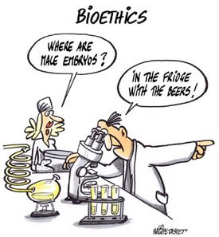](http://www.google.co.uk/url?sa=i&rct=j&q=&esrc=s&source=images&cd=&cad=rja&uact=8&ved=2ahUKEwi9orSh8KziAhVMUxUIHSQqC8EQjRx6BAgBEAU&url=/url?sa%3Di%26rct%3Dj%26q%3D%26esrc%3Ds%26source%3Dimages%26cd%3D%26ved%3D2ahUKEwipxo-P8KziAhX4VRUIHSo7AoEQjRx6BAgBEAU%26url%3Dhttps%3A%2F%2Fwww.good.is%2Farticles%2Fbioethics-is-gaining-traction-in-high-school-curriculums%26psig%3DAOvVaw3oa8MbHPAW7rX2PZkxraq7%26ust%3D1558536759367918&psig=AOvVaw3oa8MbHPAW7rX2PZkxraq7&ust=1558536759367918)Older mothers (normally given a blood test first which is safer but less accurate)

**Genetic screening – ethical and moral issues**

If a foetus is diagnosed with a genetic condition the potential parents have a real dilemma. Is abortion an option? Also;

* who decides who will be tested? How serious should the genetic condition be?
* is there an acceptable risk of amniocentesis compared to blood tests?
* should cost of screening compared to treating a disease be a factor?
* the dilemma for carriers of genetic conditions after a test that diagnoses abnormalities?
* [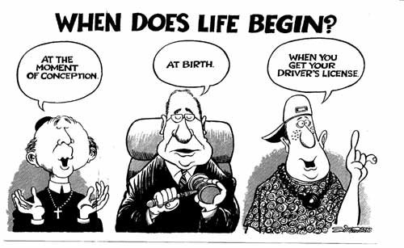](http://www.google.co.uk/url?sa=i&rct=j&q=&esrc=s&source=images&cd=&cad=rja&uact=8&ved=2ahUKEwjrgOXc6a7iAhWLSxUIHcumAtAQjRx6BAgBEAU&url=/url?sa%3Di%26rct%3Dj%26q%3D%26esrc%3Ds%26source%3Dimages%26cd%3D%26ved%3D2ahUKEwi_zs_Y6a7iAhUNSRUIHRYDDtUQjRx6BAgBEAU%26url%3Dhttps://peped.org/philosophicalinvestigations/abortion/%26psig%3DAOvVaw2nzgmC6GX2ScnYRKI0Tty1%26ust%3D1558603679704513&psig=AOvVaw2nzgmC6GX2ScnYRKI0Tty1&ust=1558603679704513)should genetic information be available to wider society, e.g. insurance companies?

**Genetic engineering - Insulin production (higher)**

[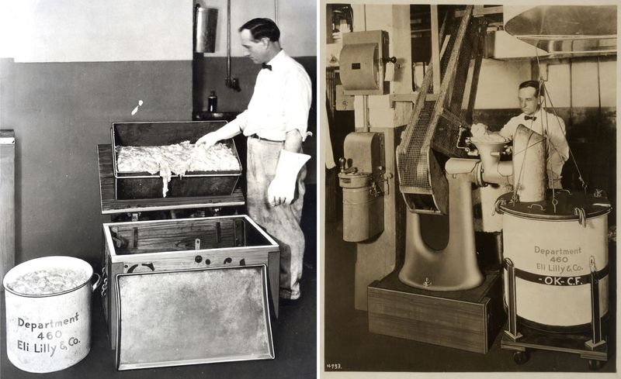](https://www.google.co.uk/url?sa=i&rct=j&q=&esrc=s&source=images&cd=&ved=2ahUKEwiK84m5-LPiAhXTSBUIHdzuB2IQjRx6BAgBEAU&url=https://americanhistory.si.edu/blog/2013/11/two-tons-of-pig-parts-making-insulin-in-the-1920s.html&psig=AOvVaw0_DaOI7CYzqx4dx1FWIyOC&ust=1558779514806364)Prior to genetic engineering, insulin to treat diabetes had to be extracted from animals. This not ideal as;

* The amount of insulin available was limited by the number of animals (pigs, cattle) brought to abattoirs for slaughter
* Extraction was time consuming and carried a risk of infection
* Using animal insulin was an ethical issue for some people
* Non-human insulin is slightly different in structure and was less effective

Genetic engineering now allows pure forms of human insulin to be produced quickly, cheaply and in greater quantities.

|  |  |  |
| --- | --- | --- |
|  |  |  |
|  |  | Insulin gene |
|  |  |  |

Transfer of a human insulin gene into the plasmid of a bacterial cell

Genetically modified bacterium

Reproduction of modified bacteria in a Fermenter

Bacterial plasmid

The enzymes that cut and isolate the human insulin gene and cut the bacterial plasmid are called **restriction enzymes**. These cut the DNA in such a way that one of the two strands extends further than the other one. The longer strand will have ‘free’ exposed bases that are not paired. The key is that each restriction enzyme will leave complementary sections of exposed bases in both the plasmid and the human insulin gene so that they can join by base pairing between each other. The exposed strands of DNA are called ‘**sticky ends’** *(Velcro)*.

[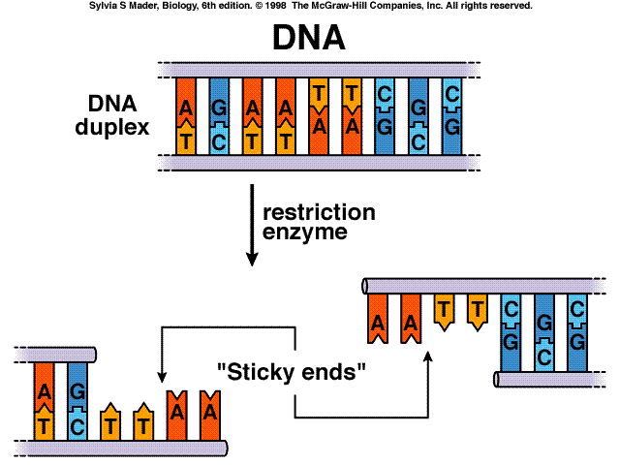](http://www.google.co.uk/url?sa=i&rct=j&q=&esrc=s&source=images&cd=&ved=2ahUKEwjelMzi9rPiAhVcVBUIHUd7AikQjRx6BAgBEAU&url=http%3A%2F%2Fbvetmed1.blogspot.com%2F2013%2F01%2Frestriction-fragments-mutations.html&psig=AOvVaw3R3bhDn6_MeLGIhi12bCmY&ust=1558778571311579)

The insulin produced by the Genetically modified bacteria needs to be extracted from the fermenter, purified and packaged – this is called **downstreaming**.