Unit 2: Body Systems, Genetics, Microorganisms and Health
2.6 Health, disease, defence mechanisms and treatments
Content - CCEA Double Award Biology 2 – Fort Hill Integrated College | Got it | Nearly | Haven’t a clue
2.6 Health, disease, defence mechanisms and treatments
Can you define health as being free from communicable and non-communicable disease;
Can you explain the costs to society of communicable and non-communicable diseases, including the economic cost of treatment for the National Health Service;
Communicable diseases
Can you demonstrate knowledge and understanding of the types of communicable diseases caused by microorganisms, how they are spread, prevented and treated, including:
- bacteria (chlamydia, salmonella and tuberculosis);
- viruses (HIV leading to AIDS, cold and flu and human papilloma virus (HPV)); and
- fungi (athlete’s foot and potato blight); and
Aseptic techniques
Can you describe how to safely use aseptic techniques to grow uncontaminated colonies of bacteria in nutrient broth or on an agar plate, including:
- sterilising Petri dishes, culture media, inoculating loops and culture bottles by autoclaving, flaming and alcohol to kill unwanted microorganisms;
- needing to keep Petri dishes partially covered and to work near a Bunsen burner during inoculation to reduce the risk of contamination by microorganisms from the air;
- incubating sealed Petri dishes at a maximum temperature of 25°C to avoid growth of pathogens; and
- cleaning work surfaces and hands and safely disposing of bacterial cultures by autoclaving.
The body’s defence mechanisms
Can you demonstrate knowledge and understanding of the body’s defence mechanisms, including:
- the skin, mucous membranes and blood clotting;
- the production of antibodies by white blood cells (lymphocytes) in response to antigens;
- the role of antibodies in defence – antibody-antigen reaction, clumping, reduced spread of disease microorganisms and symptoms;
- the role of phagocytes in engulfing and digesting microorganisms;
- the role of memory lymphocytes in a secondary response; and
- immunity, in terms of active and passive;
Antibiotics
Can you demonstrate knowledge and understanding that antibiotics, for example penicillin, are chemicals produced by fungi that are used against bacterial diseases to kill bacteria or reduce their growth;
Antibiotic resistant bacteria
Can you demonstrate knowledge and understanding of the implications on the health of the population of:
- overuse of antibiotics leading to bacterial resistance, resulting in the development of superbugs such as MRSA; and
- procedures to reduce the incidence of superbugs and why they are difficult to eradicate; and
Vaccinations
Can you demonstrate knowledge and understanding of the role of vaccines, including:
- the use of modified disease-causing organisms to produce raised antibody levels and memory lymphocyte levels in the blood; and
- the role of booster vaccinations and the interpretation of graphs of blood antibody levels.
Non-communicable diseases
Can you recall that many non-communicable diseases may involve interactions between different types of disease and are caused by the interaction of these factors:
- inherited – some people may carry a gene that predisposes them to some cancers; and
- lifestyle, including:
  - poor diet: excess sugar and fat intake;
  - lack of exercise: energy used in exercise being lower than energy intake is the cause of obesity;
  - overexposure to the Sun: ultraviolet (UV) radiation causes mutations leading to skin cancer;
  - misuse of drugs:
    - alcohol: binge drinking can cause liver disease and affect foetal development (foetal alcohol syndrome);
    - tobacco smoke:
      - tar can cause bronchitis (narrowing of bronchi and bronchioles), emphysema (damage to alveoli reducing the surface area for gas exchange) and lung cancer (abnormal cell division);
      - nicotine is addictive and affects heart rate;
      - carbon monoxide combines with red blood cells to reduce the oxygen-carrying capacity of the blood; and
Can you describe the interactions between different types of disease: obesity causing cardiovascular diseases and Type 2 diabetes.
Heart attacks and strokes
Can you demonstrate knowledge and understanding of the cause and effect of a blockage in a blood vessel:
- a blockage caused by a build-up of cholesterol deposits leads to clot formation;
- restricted blood flow means less oxygen and glucose reaching cells, and the resulting reduced cell respiration leads to cell death;
- a blockage in the coronary blood vessels restricts blood flow to the heart muscle and causes death of heart muscle cells (heart attack); and
- a blockage in the blood vessels to the brain causes death of brain cells, resulting in reduced brain function (stroke);
Can you explain these treatments for cardiovascular disease:
- angioplasty and stents; and
- statins and aspirin;
Can you recall that certain lifestyle factors increase or reduce the risk of heart disease and strokes (excess dietary fats, smoking, stress and lack of exercise);
Cancer
Can you recall that uncontrolled cell division produces cancer cells, which can result in two types of tumour: benign (encapsulated and not spreading) and malignant (capable of spreading); and
Can you appreciate how lifestyle choices can affect the risk of developing certain types of cancer, for example cervical (HPV vaccine), lung (smoking) and skin (UV radiation).

B2.6 Health, disease, defence mechanisms and treatments
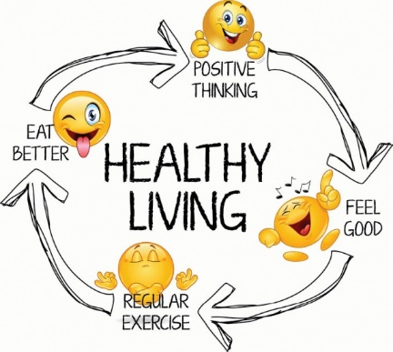
Health
Definitions:
- health is defined as being free from communicable and non-communicable disease
- a communicable disease is a disease that can be passed from one organism to another
- a non-communicable disease is not contagious
Whilst personal health is important to us, it is also important to society. Unhealthy people may not be able to work. The NHS spends billions of pounds each year treating people
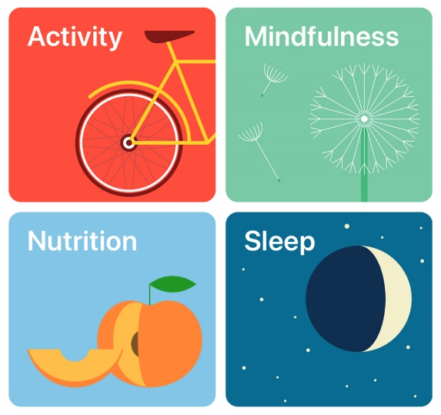

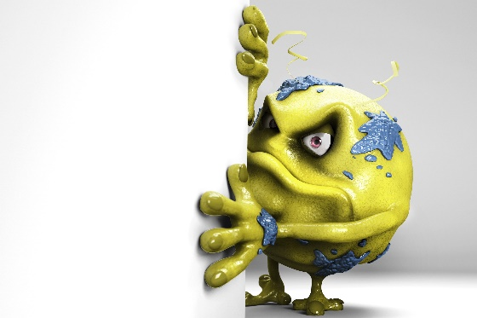
Communicable diseases
Most communicable diseases are caused by microorganisms such as bacteria, viruses and fungi. (pathogens)
Microbe | Type | Spread | Control/Prevention/treatment
HIV (which leads to AIDS) |  | Exchange of body fluids during sex  Infected blood | Condom / Abstinence  Not sharing needles
Colds and Flu |  | Airborne (droplet infection) | Flu vaccination for targeted groups
Human Papilloma Virus (HPV) |  | Sexual contact | HPV vaccination offered to 12-13 year old girls to protect against cervical cancer
Salmonella |  | Contaminated food | Cooking food thoroughly  Don’t mix cooked/uncooked food  Treated with antibiotics
Tuberculosis |  | Airborne (droplet infection) | If contracted, treated with drugs including antibiotics
Chlamydia |  | Sexual contact | Condoms reduce risk of infection  Treated with antibiotics
Athlete’s foot |  | Contact | Avoid direct contact where spores are likely e.g. wear flip-flops in changing rooms
Potato blight |  | Spores spread in the air from plant to plant, particularly in humid and warm conditions | Crop rotation and spraying plants with fungicide

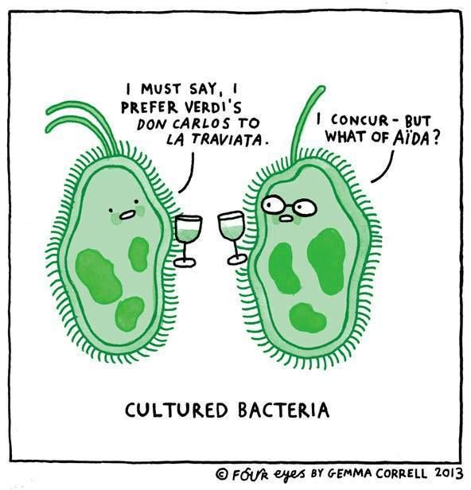
Aseptic techniques
It is important to grow (culture) microbes safely e.g. to investigate the effect of different antibiotics on their growth. Culturing microbes involves three steps;
Inoculate Plate Incubate

The following method describes how to grow uncontaminated colonies of bacteria in nutrient broth or on an agar plate;

- sterilise Petri dishes, culture media, inoculating loops and culture bottles by autoclaving, flaming and alcohol to kill unwanted microorganisms;
- keep Petri dishes partially covered and work near a Bunsen burner during inoculation to reduce the risk of contamination by microorganisms from the air;
- incubate sealed Petri dishes at a maximum temperature of 25°C to avoid growth of pathogens;
- clean work surfaces and hands and safely dispose of bacterial cultures by autoclaving to avoid contamination.
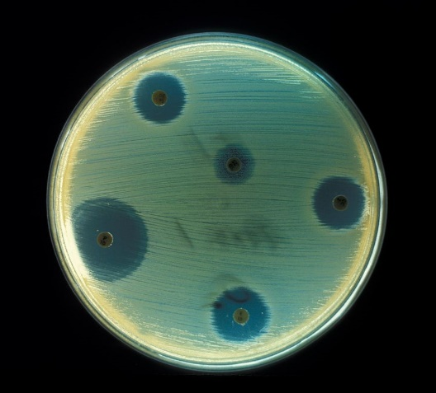

Aseptic Technique
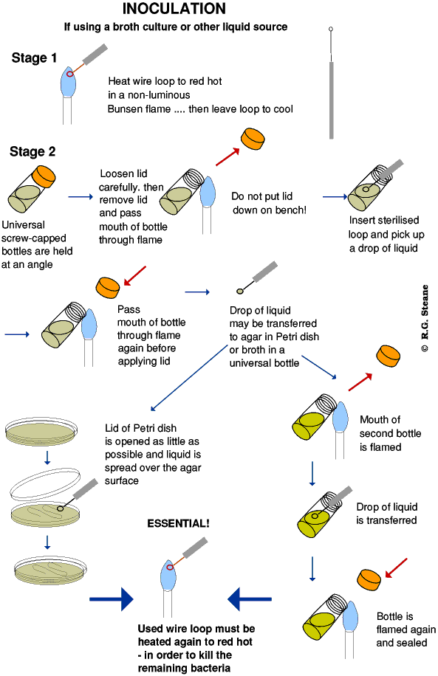

Defence mechanisms of the body
Our first line of defence is trying to prevent microbes from entering our bodies. Our s……………… is a physical barrier and if broken we quickly seal the cut by our b………………… c……………………… Mucus membranes line our breathing system which traps airborne microbes.
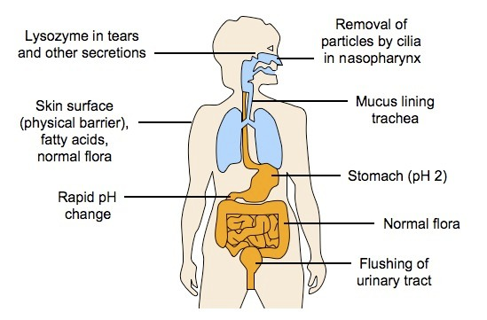

The Immune system
If a microbe does enter the body, the Immune system (white blood cells) usually helps combat the invader. There are 2 main types of white blood cells;
- Lymphocytes –produce antibodies in response to antigens (chemicals on the surface of microbes)
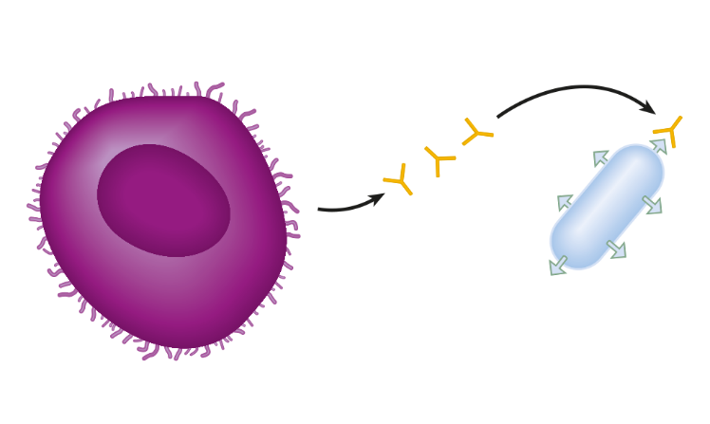
Antibodies
Lymphocyte

Microbe (antigens on outside

Antibodies have a complementary shape that matches the shape of the antigens on the microbe. This creates an antibody-antigen reaction making microbes clump together. Once clumped (immobilised) they cannot reproduce and spread and are easily destroyed by phagocytes.
Primary and secondary responses
After being infected by a bacterium or virus, the infected individual is often ill for a few days before the antibody numbers are high enough to provide immunity. This is described as the primary response. However, once infected, the body is able to produce memory lymphocytes that remain in the body for many years. This means that if infection by the same microbe occurs again, the memory lymphocytes will be able to produce antibodies very fast to stop the individual showing the symptoms of the same disease again. This is known as the secondary response.
- Phagocytes – these engulf and digest microbes (phagocytosis)

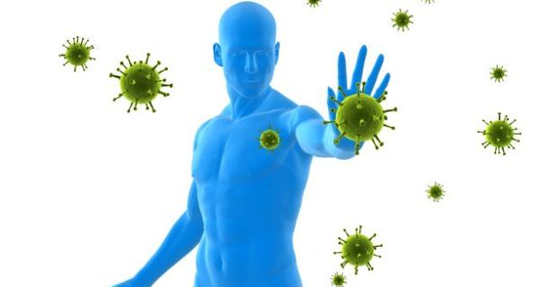
Immunity
Individuals who are protected against a particular disease are described as being immune to it. This means that their antibody levels are high enough (or can be produced quickly enough) to combat the microorganism should it gain entry to the body again. There are 2 types of immunity;
Active immunity – the body produces antibodies (slower acting/long protection)
Passive immunity – antibodies from another source e.g. medicine, breastmilk (fast acting/ short lasting)

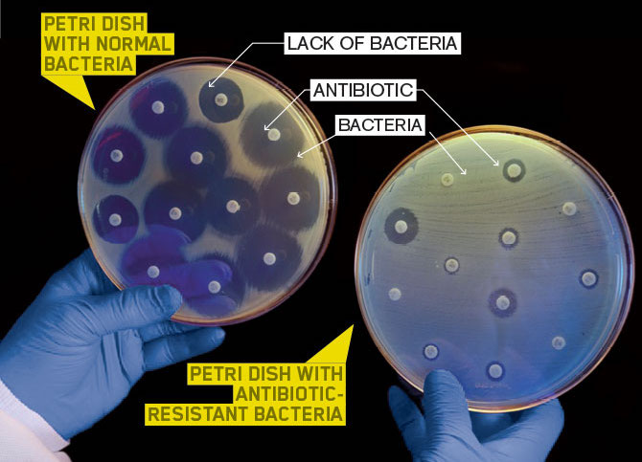
Antibiotics
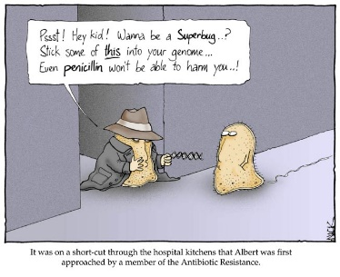
Antibiotics e.g. penicillin, are chemicals produced by fungi that are used against bacterial diseases to kill bacteria or reduce their growth.

Antibiotic resistant bacteria (Higher)
We have already looked at the rise of antibiotic resistance as an example of Natural Selection;
Stage 1  Bacteria reproduce |  |  |  | Stage 2  Treated with antibiotic |  | Stage 3  Offspring of survivors
 |  |  |  |  | These bacteria are killed by the antibiotic
 |  |  |  |  |  |  | Mutated bacteria survive and multiply
Key
 | Normal bacteria
 | Bacteria with a mutation that gives resistance to the antibiotics used in stage 2

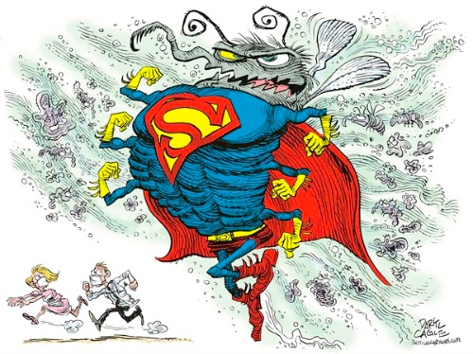
The overuse of antibiotics has allowed many types of bacteria to become resistance to the main antibiotics. Bacterial resistance to antibiotics is becoming a major problem, making many diseases much harder to treat and surgical procedures more dangerous due to the risk of infection.
Some bacteria have developed resistance to the extent that they are now referred to as ‘superbugs’ e.g. MRSA. These cause very serious problems in hospitals and are extremely difficult to eradicate because;
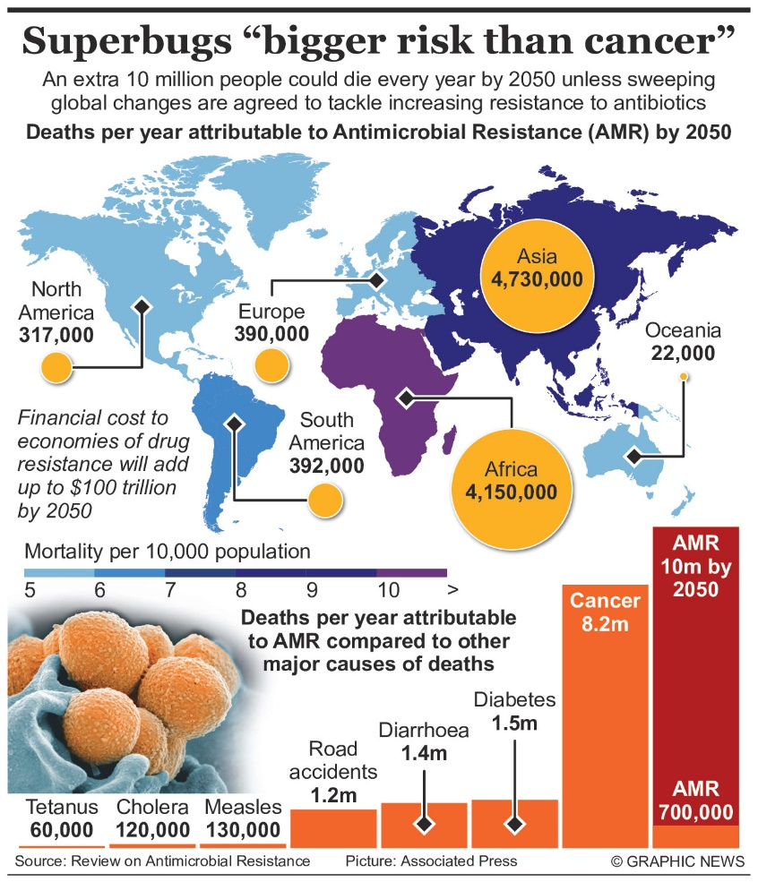
- Patients may have weak immune systems or wounds to allow the superbugs to enter their bodies
- Hospitals are ‘antibiotic rich’ environments, aiding the natural selection of superbugs
- Possible poor hygiene in some hospitals?
New measures to deal with super bugs include;
- Increased hygiene e.g. hand sanitisers, immediate cleaning of spillages of body fluids, wearing gloves
- Greater care administrating antibiotics
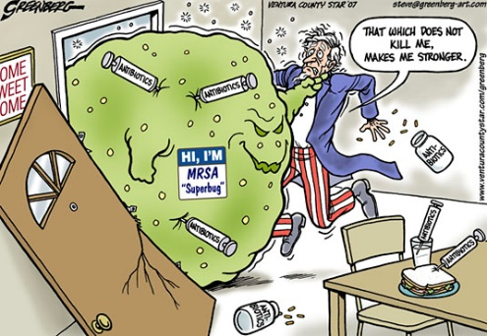
- Isolation of patients who contract superbugs

Vaccinations
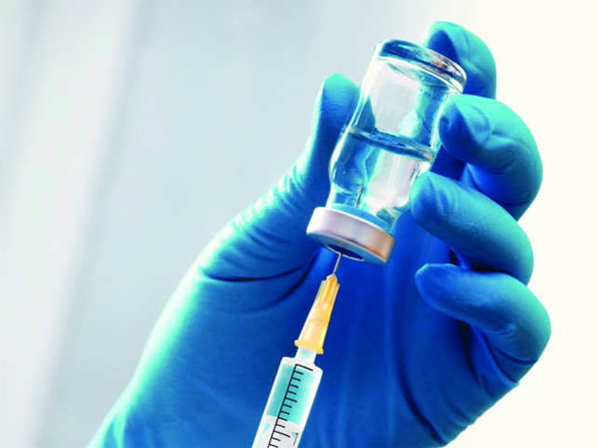
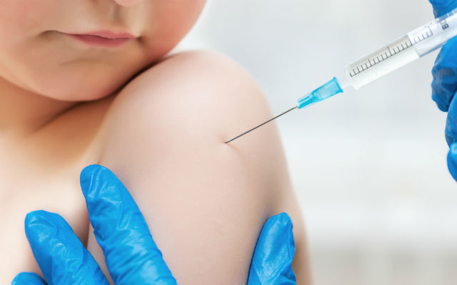
Vaccinations involve the use of dead or modified pathogens that are injected into the body. These still have the antigens on their surface that cause lymphocytes to produce antibodies at a high enough level to prevent the individual becoming ill later. Crucially, a vaccination leads to memory lymphocytes being produced that will bring about a rapid immune response if a further infection occurs.
(Higher) Sometimes we need more than one vaccination to make sure that we remain immune for a reasonable period of time. This is known as a follow-up booster vaccination. (Higher tier pupils need to be able to interpret graphs of blood antibody levels.)

Level of antibody
Required to produce immunity
Time / months
Level of antibody

Immunity in action
Level of antibody
Required to produce immunity
Time / months
Level of antibody

Active immunity – antibodies are produced by the body in response to infection. The relatively slow increase in antibody number is typical of the primary immune response – gaining immunity following infection by a type of microorganism for the first time.
Level of antibody
Required to produce immunity
Time / months
Level of antibody

Passive immunity – antibody levels increase rapidly but fall quickly also.

The difference in the speed of the body producing antibodies following a first infection (primary response) and being reinfected by the same pathogen (secondary response) are shown below:

Time / months
Level of antibody

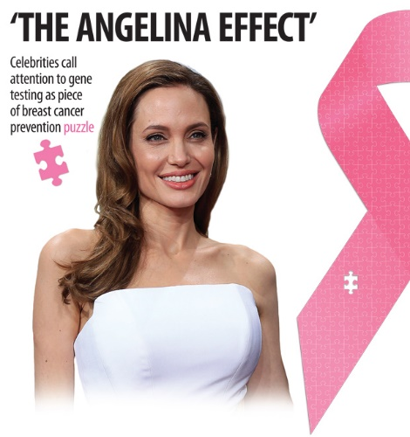
Non-communicable diseases
Non-communicable diseases are not contagious. However, there may be interactions between different types of disease caused by combinations of 2 factors;
- Inherited – some people may carry a gene that predisposes them to some cancers; and
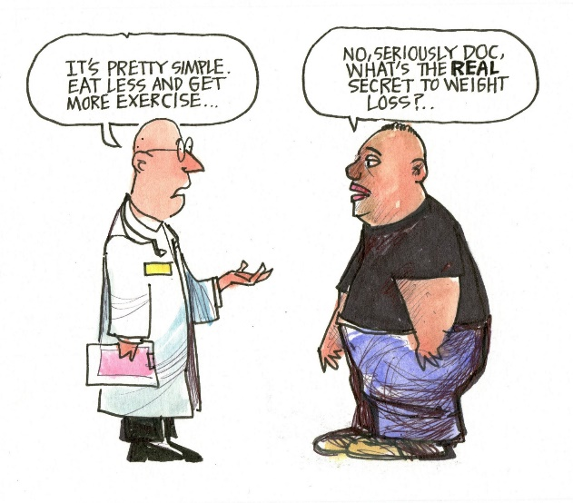
- Lifestyle
  - poor diet: excess sugar and fat intake;
  - lack of exercise: energy used in exercise being lower than energy intake is the cause of obesity;
  - overexposure to the Sun: ultraviolet (UV) radiation causes mutations leading to skin cancer;
  - misuse of drugs:
    - alcohol: binge drinking can cause liver disease and affect foetal development (foetal alcohol syndrome);
    - tobacco smoke:
      - tar can cause bronchitis (narrowing of bronchi and bronchioles), emphysema (damage to alveoli reducing the surface area for gas exchange) and lung cancer (abnormal cell division);
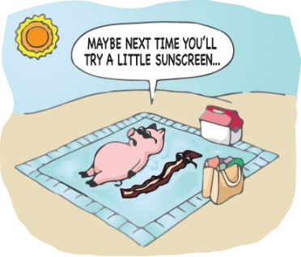
      - nicotine is addictive and affects heart rate;
      - carbon monoxide combines with red blood cells to reduce the oxygen-carrying capacity of the blood.

Interactions between different types of disease:
Obesity causes cardiovascular diseases and Type 2 diabetes.

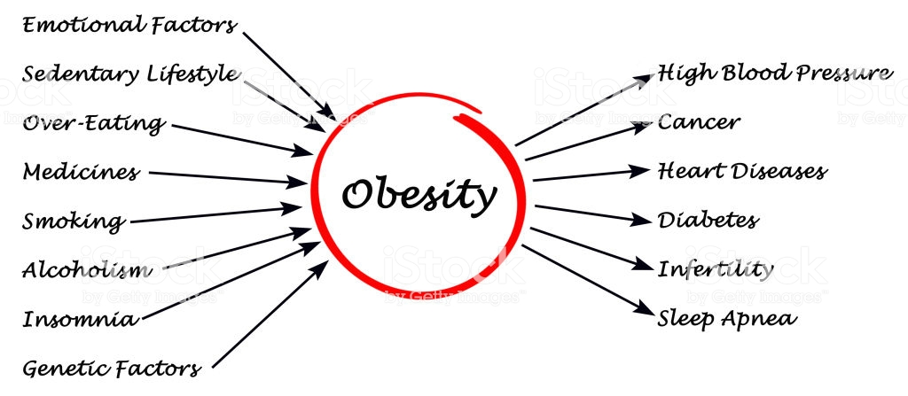

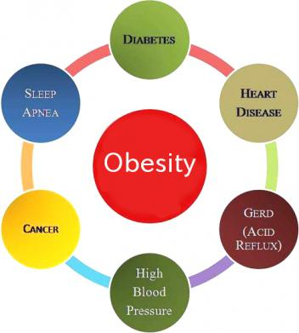

Heart attacks and strokes
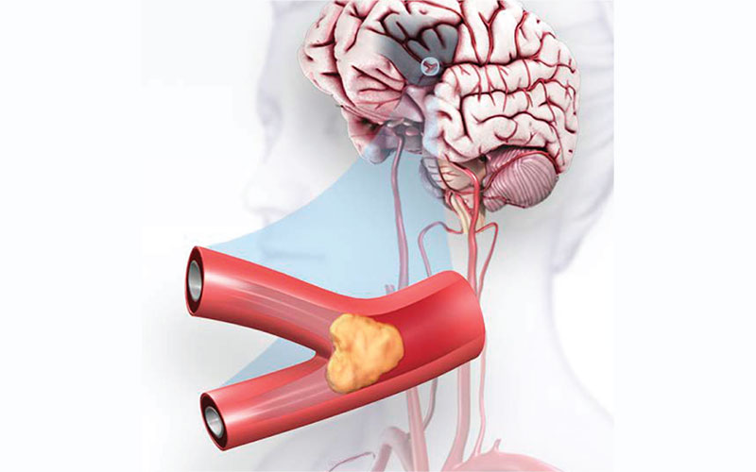
Both Heart attacks and strokes are caused by blockages in blood vessels.
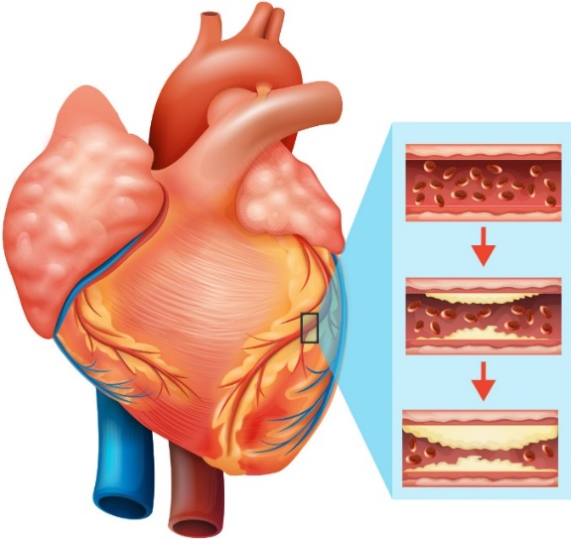

- The blockage in the blood vessel is created by a build-up of cholesterol deposits which leads to clot formation
Lifestyle factors can increase the risk of heart disease and strokes (excess dietary fats, smoking, stress and lack of exercise)
- Restricted blood flow means less oxygen and glucose reaching cells, and the resulting reduced cell respiration leads to cell death;
- a blockage in the coronary blood vessels restricts blood flow to the heart muscle and causes death of heart muscle cells (heart attack); and
- a blockage in the blood vessels to the brain causes death of brain cells, resulting in reduced brain function (stroke);

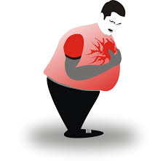
Treatments for cardiovascular disease

- Surgical - Angioplasty and stents
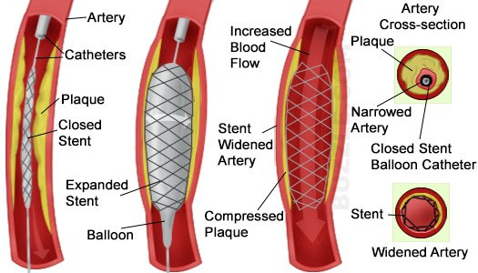
A coronary angioplasty is a procedure used to widen blocked or narrowed coronary arteries. The term ‘angioplasty’ means using a balloon to stretch open a narrowed or blocked artery. The stent is a mesh like structure that is left behind to hold the blood vessel open

- Drugs - statins and aspirin
Statins help reduce blood cholesterol and therefore the rate at which blood vessels can become clogged up with fatty deposits.
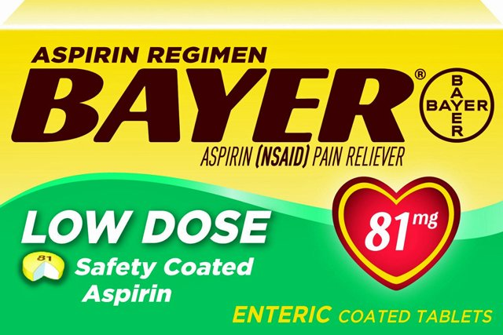
Aspirin is similar in that is helps ‘thin’ the blood, making it less ‘sticky’, reducing the risk of a clot forming in the narrowed blood vessels. Low doses of aspirin are often given to people who have had a heart attack or stroke.

Cancer
Cancer is uncontrolled cell division, which can result in two types of tumour:
- benign (encapsulated and not spreading through the body) and;

- malignant groups of cancer cells may break off from the main tumour and spread around the body, where they can grow into other (secondary) tumours. Usually much more dangerous.
As with most non-communicable diseases, lifestyle choices can affect the risk of developing cancer e.g. cervical (HPV vaccine), lung (smoking) and skin (UV radiation).

