Chemistry Unit C1: Structures, Trends, Chemical Reactions, Quantitative Chemistry and Analysis
C1.7 Quantitative chemistry
Content - CCEA Double Award Chemistry 1 – Fort Hill Integrated College | Got it | Nearly | Haven’t a clue
C1.7 Quantitative chemistry
Formula mass
Can you recall that the relative atomic mass (Ar) of an atom is the mass of the atom compared with that of the carbon-12 isotope, which has a mass of exactly 12, and demonstrate knowledge and understanding that Ar is a weighted mean of the mass numbers;
Can you calculate the relative formula mass (Mr) (relative molecular mass) of a compound and the percentage of an element, by mass, in a compound;
The mole
Can you demonstrate knowledge and understanding that chemical amounts are measured in moles and that the mass of one mole of a substance in grams is numerically equal to the relative formula mass;
Can you convert the given mass of a substance to the amount of the substance in moles (and vice versa) by using the relative atomic or formula mass;
Can you calculate the reacting masses of reactants or products, given a balanced symbol equation and using moles and simple ratio, including examples where there is a limiting reactant;
Percentage yield
Can you calculate the theoretical yield and the percentage yield of a chemical reaction given the actual yield;
Can you recognise possible reasons why the percentage yield of a product is less than 100%, including loss of product in separation from the reaction mixture, as a result of side reactions or because the reaction is reversible and may not go to completion.

Quantitative Chemistry
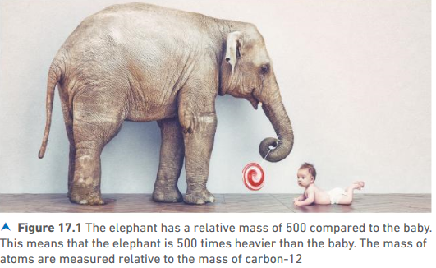
Relative Atomic mass (A_{r})
Atoms have a tiny mass e.g. C-12 atom is 2.0x10⁻²⁴g – too small to measure. Chemists measure the mass of atoms RELATIVE to each other.

In Chemistry we compare the mass of an atom with the mass of a carbon-12 isotope which has a mass of exactly 12. The mass of an atom is the MEAN mass of its Isotopes. (see atomic structure chapter).
To find the A_{r} of an Element, simply look at your periodic table and take the mass number (larger).
Relative Formula Mass (M_{r})
The formula mass of a compound is the A_{r} of all the elements present. Be careful as sometimes there are more than one of the same atom!

Example: MgCl₂ | Example: H₂SO₄
(1 x Mg) + 2 (Cl) | (2xH) + (S) + (4xO)
1x24 + 2(35) | (2x1) + 32 + (4x16)
= 24 + 70 = 94 | = 2 + 32 + 64 = 98

Find the M_{r} of these compounds:
- NaCl | - SiO₂
- Cl₂ | - Li₂O
- CaCO₃ | - CCl₄
- HCN | - H₂PO₄
- Mg(OH)₂ | - Al₂(CO₃)₃
Percentage of an element in a compound
To find the percentage of an element, by mass, in a compound;
% of Ca in CaCO₃ | % Al in Al₂(CO₃)₃
M_{r} of CaCO₃ = 100 | M_{r} of Al₂(CO₃)₃ = 234
A_{r} of Ca = 40 | A_{r} of Al x 2 = (27 x 2) = 54
40/100 x 100 = 40% | 54/234 x 100 = 23.08%
The Mole
Even a very small amount of substance such as a pinhead is made of millions of atoms – a much bigger “number” is needed! A more convenient measure called a Mole is used.
The number is often referred to as the Avogadro constant. It is just a word to describe this really massive number like dozen, couple, score.
A mole of atoms contains 6 x 10²³ atoms.
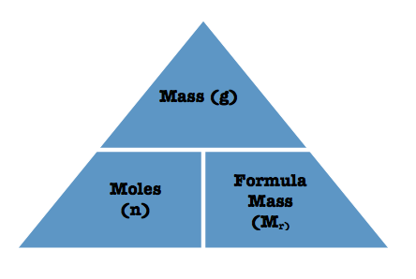
There is a formula that can be used to convert moles, masses and M_{r}:

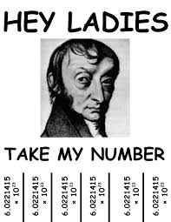
1 mole of a substance has a mass of its M_{r} in grams.

Example 1: Calculate the number of moles in 4.9g of H₂SO₄
Find M_{r} H₂SO₄ first = (2x1) + (32) + (4x16) = 98
Moles = Mass (g) / M_{r} = 4.9/98 = 0.05 mol

Example 2: Find the mass of 20 moles of CO₂
M_{r} CO₂ = (12) + (2x16) = 12 + 32 = 44
Mass = M_{r} x moles = 44 x 20 = 880g

Test yourself
- What is the mass of one of mole of the following?
mass = mole x M_{r}
  - NaCl mass = 1 x (23+35) = 58g
  - Ca
  - H₂SO₄
  - Mg(NO₃)₂
  - (NH₄)₂SO₄

- Calculate the number of moles in:
  - 12g of H₂SO₄
  - 16g of Mg(OH)₂
  - 50g of CaCO₃
  - 54g of Al₂(SO₄)₃
  - 4g of O₂
  - 5.6g of Ca(OH)₂
- Calculate the mass in grams of:
  - 0.5 mole of FeSO₄
  - 0.1 mole of MgO
  - 0.125 mole of CuO
  - 2 moles of Ca(OH)₂
  - 4 moles of Na₂CO₃
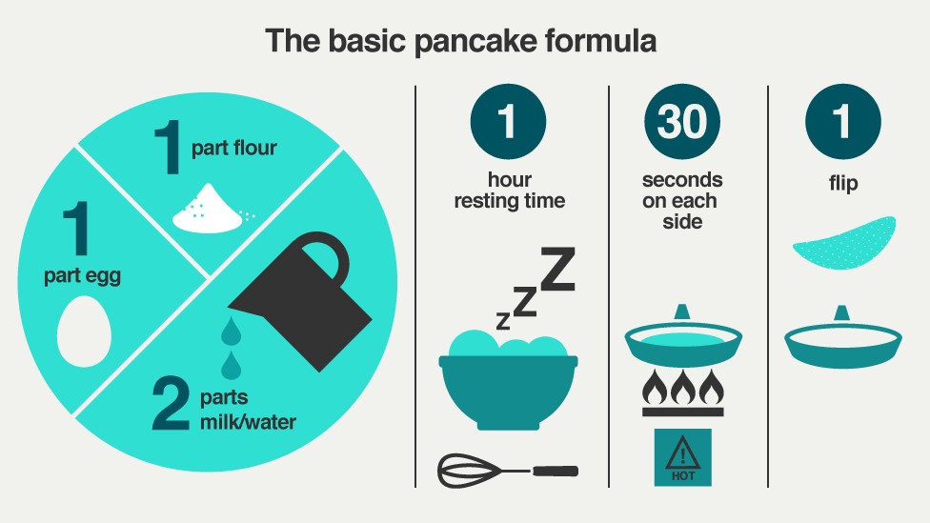
Mole ratios - HIGHER
A ratio is a way to compare the quantities of something e.g. mixing cement or cooking rice. In a balanced symbol equation, the substances are in ratio. The balancing numbers give the ratio of moles that react together.

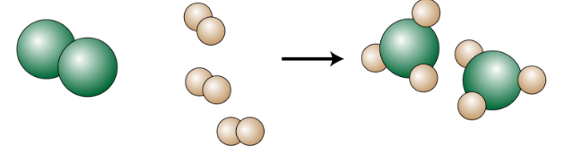
N₂ | + | 3H₂ |  | 2NH₃
1 mole N₂ | Reacts with | 3 moles of H₂ | To form | 2 moles of NH₃
Ratio: | 1 mole N₂: 3 moles H₂: 2 moles NH₃

Examples
- 2Mg + O₂ 2MgO
The ratio of Mg: O₂ is 2:1
So if I have 6 moles of Magnesium I will need 3 mole of oxygen to react with it.

- 4Al + 3O₂ 2Al₂O₃
How many moles of aluminium are needed to produce 0.76 moles?
of Aluminium oxide?
Al: Al₂O₃ = 4:2 = 2:1
So always twice as many Aluminium moles required as aluminium oxide produced.
So 0.76 mole of Aluminium oxide requires 2 x 0.76 = 1.52 mole

Test yourself
- In the reaction shown the copper nitrate is heated until it has all decomposed.
2Cu(NO₃)₂ 2CuO + 4NO₂ + O₂

- How many moles of O₂ are produced from 4 moles of Cu(NO₃)₂?
- How many moles of NO₂ are produced from 0.6 moles of Cu(NO₃)₂?

- In the reaction
CaO + 3C CaC₂ + CO
- How many moles of carbon are needed to completely react with 0.33 moles of CaO?
- How many moles of CO are produced when 3.3 moles of carbon react completely?

- In the reaction
2H₂ + O₂ 2H₂O
- How many moles of H₂O are produced if 0.5 moles of hydrogen completely react?
- How many moles of water are produced if 0.1 moles of oxygen completely react?
- How many moles of hydrogen react if 0.4 moles of oxygen completely react?
- How many moles of oxygen react if 10 moles of hydrogen completely react?

- In the reaction
3Pb + 2O₂ Pb₃O₄
  - How many moles of oxygen are needed to completely react with 0.66 moles of lead?
  - How many moles of Pb₃O₄ are produced when 2.2 moles of oxygen completely react?
  - How many moles of Pb₃O₄ are produced when 0.33 moles of lead completely react?

- Potassium chlorate (KClO₃) decomposes to form potassium chloride and oxygen, as shown in the equation:
2KClO₃ 2KCl + 3O₂
  - How many moles of potassium chloride are formed when 10 moles of potassium chlorate completely decompose?
  - How many moles of oxygen are formed when 4 moles of potassium chlorate completely decompose?
  - How many moles of potassium chloride are formed when 0.5 moles of potassium chlorate completely decompose?

Calculating reacting masses of reactants and products (Higher)
Chemists need to be able to calculate how much of each reactant to use in a chemical reaction.
To do this we need to combine the last two steps:
- Underline the 2 substances you are dealing with in the equation
- Calculate M_{r} of the substance you have information about and calculate the number of moles
- Use the ratio from the balanced equation to calculate the number of moles of the substance you need to find the mass of
- Calculate the mass = moles x M_{r}
Example
What mass of magnesium carbonate reacts with 3.62g of HCl?

MgCO₃ + 2HCl MgCl₂ + H₂O + CO₂
3.62g
M_{r} (HCl) = 1 + 35.5 = 36.5
moles HCl = mass/ M_{r} = 3.65/36.5 = 0.1mol
ratio – 2HCl : 1MgCO₃
  - : ?
  - : 0.1/ 2
  - : 0.05
M_{r} of MgCO₃ = 24 + 12 + (16x3) = 84
mass MgCO₃ = moles x Mr
= 0.05 x 84 = 4.2g

Test yourself
- What mass of oxygen is needed to completely react with 10g of hydrogen?
2H₂ + O₂ 2H₂O

- What mass of calcium oxide is formed from complete decomposition of 25g of calcium carbonate?
CaCO₃ CaO + CO₂

- What mass of magnesium oxide would be made from complete reaction of 3g of magnesium with oxygen?
2Mg + O₂ 2MgO

- Lithium reacts with water as shown in the equation below. What mass of hydrogen would be produced from complete reaction of 1.4g of lithium?
2Li + 2H₂O 2LiOH + H₂

- What mass of calcium carbonate is needed to completely react with 3.65g of HCl?
CaCO₃ + 2HCl CaCl₂ + H₂O + CO₂

- What mass of NO₂ is obtained from complete decomposition of 33.1g of lead nitrate?
2Pb(NO₃)₂ 2PBO + 4NO₂ + O₂

Limiting reactant (Higher)

In a chemical reaction the reactant that ____________________ is the limiting reactant. This is best illustrated in Baking!

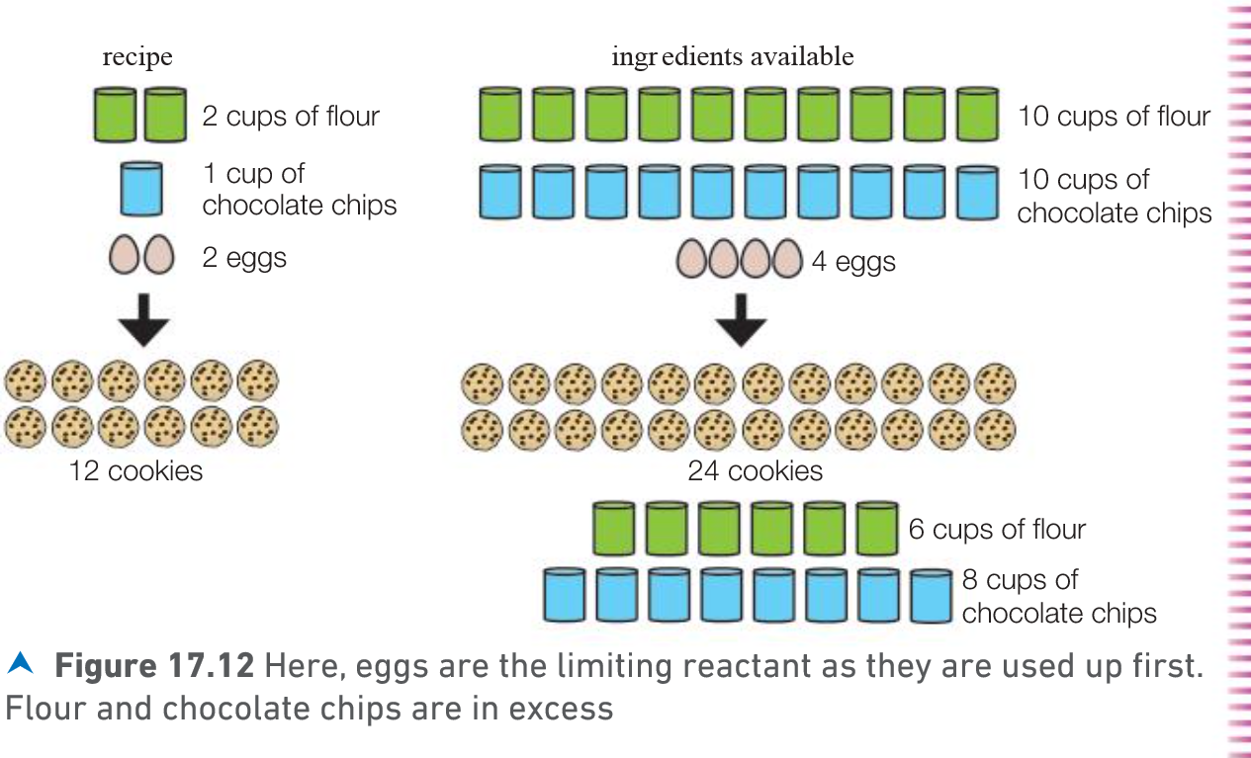

If one reactant is in excess this means _____________________ ___________________________________________________.
We use this knowledge if one of the reactants in the production of chemicals is very expensive. The cheaper reactant will be added in excess to ensure _____________________________________.
When fuels are burned an excess of ___________ is used as fuels are expensive and in limited supply.
Example:
5 moles of Zn are added to 7 moles of H₂SO₄. One of the reagents is in excess.
Zn + H₂SO₄ ZnSO₄ + H₂
- Which reactant is in excess?
- Calculate the number of zinc sulfate and hydrogen formed.

 | Zn | + | H₂SO₄ |  | ZnSO₄ | + | H₂
Reacting ratio from the equation | 1 mole of Zn | Reacts with | 1 mole of H₂SO₄ | To make | 1 mole of ZnSO₄ | and | 1 mole of H₂
Amount provided | 5 moles of Zn  Limiting reactant |  | 7 moles of H₂SO₄  In excess so it does not all react
Reaction that takes place | 5 moles of Zn | Reacts with | 7 moles of H₂SO₄ | To make | 5 mole of ZnSO₄ | and | 5 mole of H₂

Test yourself
- Copper (II) oxide reacts with hydrogen according to the equation;
CuO + H₂ Cu + H₂O
How many moles of copper would be made if;
- 10 moles of copper (II) oxide were reacted with 15 moles of hydrogen
- 3 moles of copper (II) oxide were reacted with 3 moles of hydrogen
- 0.6 moles of copper (II) oxide were reacted with 0.3 moles of hydrogen

- Copper (II) oxide reacts with methane as shown below;
4CuO + CH₄ 4Cu + 2H₂O + CO₂
How many moles of copper would be made if;
  - 4 moles of copper (II) oxide were reacted with 4 moles of methane
  - 3 moles of copper (II) oxide were reacted with 1 moles of methane
  - 6 moles of copper (II) oxide were reacted with 2 moles of methane

- What mass of calcium sulphide can be made when 6g of calcium reacts with 8g of sulphur?
Ca + S CaS

- What mass of calcium chloride is obtained from 20g of ammonium chloride and 50g of calcium oxide? Give your answer to two decimal places.
2NH₄Cl + CaO CaCl₂ + H₂O + 2NH₃

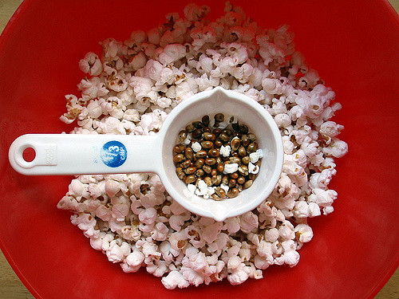
Percentage yield (P192)
Theoretical yield is _______________________________
_______________________________
Actual Yield is ___________________________________________________
___________________________________________________
The actual yield is LESS than the theoretical yield because:
- Some of the product ______________________________
_______________________________________________
- Side reactions may occur – this means that some of the
______________________________________________________________________________________________
- Some reactions do not go to completion. This means they do not ___________________________________________
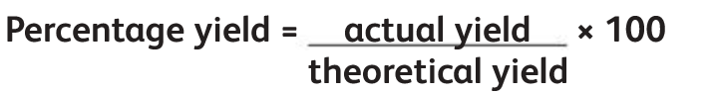
Example
In a reaction to produce aspirin, the theoretical yield was 40g but the mass of aspirin produced was 5g. Calculate the percentage yield of aspirin.
= 5/40 x 100 = 12.5%
A higher percentage yield industry means more P_______ is formed and more P_________ is made.
Test yourself
- In a reaction to produce paracetamol, the theoretical yield was 200g but the yield was actually 150g
  - Calculate the percentage yield
  - Give three possible reasons for the percentage yield being less than 100%.

- In the reaction of hydrogen with oxygen, 0.85 moles of water were produced/ The theoretical yield for the reaction is 0.95 moles. Calculate the percentage yield of this reaction.

  - What is the maximum mass of ammonium chloride that could be formed when 7.3g of HCl is neutralised by ammonia?
NH₃ + HCl NH₄Cl
  - This experiment produced only 8.3g of ammonium chloride. What is the percentage yield?

- Phenol is converted to a trichlorophenol according to the equation below.
C₆H₅OH + 3Cl₂ C₆H₂Cl₃OH + 3HCl
phenol trichlorophenol
- Calculate the theoretical yield of trichlorophenol from 47g of phenol.
- If 90.6g of trichlorophenol were actually produced, calculate the percentage yield.

