**Chemistry Unit C1: Structures, Trends, Chemical Reactions, Quantitative Chemistry and Analysis**

**C1.6 The Periodic Table**

|  |  |  |  |
| --- | --- | --- | --- |
| **Content - CCEA Double Award Chemistry 1 – Fort Hill Integrated College** | Got it | Nearly | Haven’t a clue |
| **C1.6 The Periodic Table** | | | |
| **Basic structure of the Periodic Table** |  |  |  |
| Can you describe how Mendeleev arranged the elements in the Periodic Table and left gaps for elements that had not been discovered at that time, and how this enabled him to predict properties of undiscovered elements; |  |  |  |
| Can you demonstrate knowledge and understanding of how scientific ideas have changed over time in terms of the differences and similarities between Mendeleev’s Periodic Table and the modern Periodic Table; |  |  |  |
| Can you describe an element as a substance that consists of only one type of atom and demonstrate understanding that elements cannot be broken down into simpler substances by chemical means; |  |  |  |
| Can you demonstrate knowledge and understanding that a group is a vertical column in the Periodic Table and a period is a horizontal row; |  |  |  |
| Can you identify and recall the position of metals and non-metals in the Periodic Table and distinguish between them according to their properties, including conduction of heat and electricity, ductility, malleability, melting point and sonority; |  |  |  |
| Can you identify elements as solids, liquids and gases (at room temperature and pressure) in the Periodic Table; and |  |  |  |
| Can you demonstrate knowledge and understanding that elements in the same group in the Periodic Table have the same number of electrons in their outer shell and this gives them similar chemical properties. |  |  |  |
| Can you recall that elements with similar properties appear in the same group (for example Group 1 (I) and Group 2 (II) are groups of reactive metals, Group 7 (VII) is a group of reactive non-metals and Group 0 is a group of non-reactive non-metals), locate these groups in the Periodic Table and recall the names of the groups; |  |  |  |
| **Group 1 (I)** |  |  |  |
| Can you demonstrate knowledge and understanding that the alkali metals have low density and the first three are less dense than water; |  |  |  |
| Can you assess and manage risks associated with the storage and use of alkali metals and recall that alkali metals are easily cut, are shiny when freshly cut and tarnish rapidly in air; |  |  |  |
| Can you demonstrate knowledge and understanding that Group 1 (I) metals react with water to produce hydrogen and a metal hydroxide, and give observations for the reactions; |  |  |  |
| **Can you** **demonstrate knowledge and understanding that alkali metals have similar chemical properties because when they react an atom loses an electron to form a positive ion with a stable electronic configuration;** |  |  |  |
| **Can you** **write half equations for the formation of a Group 1 (I) ion from its atom;** |  |  |  |
| Can you demonstrate knowledge and understanding of how the trend in reactivity down the group depends on the outer shell of electrons of the atoms; |  |  |  |
| Can you demonstrate knowledge and understanding that most Group 1 (I) compounds are white and dissolve in water to give colourless solutions; and |  |  |  |
| **Group 7 (VII)** |  |  |  |
| Can you recall data about the colour, physical state at room temperature and pressure, diatomicity and toxicity of the elements in Group 7 (VII), **interpret given data to** **establish trends within the group and make predictions based on these trends.** |  |  |  |
| Can you recall the observations when solid iodine sublimes on heating and demonstrate understanding of the term sublimation; |  |  |  |
| Can you describe how to test for chlorine gas (damp universal indicator paper changes to red and then bleaches white); |  |  |  |
| **Can you describe how to investigate the displacement reactions of Group 7 (VII) elements with solutions of other halides to establish the trend in reactivity within the group and make predictions based on this trend;** |  |  |  |
| Can you demonstrate knowledge and understanding of how the reactivity down the group depends on the outer shell electrons of the atoms; |  |  |  |
| **Can you recall that the halogens have similar chemical properties because when they react an atom gains an electron to form a negative ion with a stable electronic configuration;** |  |  |  |
| **Can you write half equations for the formation of a halide ion from a halogen molecule or atom;** |  |  |  |
| **Group 0** |  |  |  |
| Can youuse the concept of electronic configuration to explain the lack of reactivity and the stability of the noble gases; |  |  |  |
| Can yourecall that the noble gases are colourless gases; |  |  |  |
| **Can you describe the trend in boiling points of the Noble gases going down the group;** and |  |  |  |
| **Transition metals** |  |  |  |
| Can youdemonstrate knowledge that transition elements form ions with different charges (for example iron(II) and iron(III)) and form coloured compounds:   * copper(II) oxide is black; * copper(II) carbonate is green; * hydrated copper(II) sulfate is blue; and * copper(II) salts are usually blue in solution. |  |  |  |

The Basic structure of the Periodic Table

The periodic table arranging the different elements in patterns. An element is a substance that consists of …………………………………………………… ……………………………………………… and cannot be broken down into simpler substances by c………………… means.



Groups are vertical columns

Periods are horizontal rows

Metals and non-metals are separated by the ‘staircase’

Metals are good conductors of heat and electricity, ductile (can be pulled into wires), malleable (can be hammered into shape), have high melting points and are sonorous (make a ‘ringing sound’)

Group I = Alkali metals (reactive metals)

Group II = Alkali-Earth Metals (reactive metals)

Group VII = Halogens (reactive non-metals)

Group 0 – The Noble gases (non-reactive non-metals)

SLaG

L – liquids – Hg & Br

G –gases – All group 0; + F, Cl, H, N, O

Diatomic

H2 N2 O2 F2 Cl2 Br2 I2

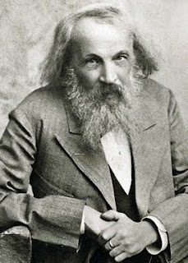(1869) Dmitri Mendeleev

Mendeleev arranged the known elements in order of atomic mass and recognised repeating patterns in chemical behaviour. He;

* let gaps for undiscovered elements
* 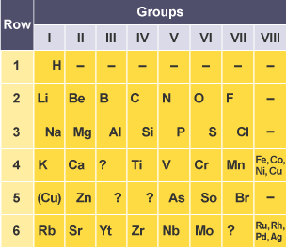switched the mass order of some elements to fit the patterns
* could predict the properties of undiscovered elements
* Nobel gases still hadn’t been discovered

Modern (2018+)

* arranged by atomic number
* more elements (with no gaps)
* Block of T…………………… metals
* includes the N………… gases
* Actinides and lanthanides are present

1. Almost a decade after Newlands, Dmitri Mendeleev produced a Periodic Table, part of which is shown below.

Using your knowledge and understanding, describe the main differences between the Modern Periodic Table and the Periodic Table developed by Mendeleev. In your answer make it clear which version of the Periodic Table you are referring to.

* **Modern Periodic Table arranged in order of atomic number**
* **Mendeleev’s Periodic Table arranged in order of atomic mass**
* **Mendeleev’s Periodic Table placed more than one element in a space**
* **Modern Periodic Table places only one element in a space**
* **Modern Periodic Table has no gaps/Mendeleev’s Periodic Table had gaps**
* **Idea that modern Periodic Table places transition elements in a separate block**
* **Mendeleev’s Periodic Table had no Noble gases/modern Periodic Table has Noble gases**
* **Modern Periodic Table has more elements/has actinides/has lanthanides**
* **Correct idea of elements moved e.g. H or e.g. I2 /Te exchanged**

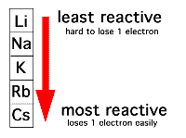

**Group I**

**Group 1 (I)** is a group of r……………….. m…………… (the ……………… metals). *They have similar p………………………. because when they react an atom ……………… ……… electron to form a ……………… ion (………………) with a stable electronic configuration.* Their reactivity increases as you go down the group (the more outer shells the more reactive).

**Physical properties -** alkali metals are ………………. cut, ………… when freshly cut and …………………… rapidly in air. The alkali metals have low density and the first three are less dense than water.

When Group 1 metals react with non-metals they form Ionic compounds which are usually coloured ………………… and which dissolve in water to form colourless solutions.

**Chemical Reactions**

1. **Reactions of Group 1 elements with water**

***Group1 metal + …………… 🡪 Group1 metal hydroxide + …….***

*e.g.*

Safety (use small amounts of metal; safety screen; gloves & safety goggles; use tongs as the metals are corrosive)

Rb, Cs & Fr are explosive in water so not done in school

<https://www.youtube.com/watch?v=_zPH0rdZrJY>

|  |  |  |  |
| --- | --- | --- | --- |
| **Observation** | **Li** | **Na** | **K** |
| Floats and moves about the surface |  |  |  |
| Gas given off |  |  |  |
| Eventually disappears |  |  |  |
| Heat released |  |  |  |
| Colourless solution |  |  |  |
| Forms a silvery ball/melts |  |  |  |
| Burns with a lilac flame |  |  |  |
| Small explosion/crackle |  |  |  |

**Half equations (Higher tier only)**

Half equations are equations that include **electrons (e-)**We construct them as follows;

|  |  |
| --- | --- |
| Step 1 | Write down the reactant and product |
| Step 2 | Balance the atoms |
| Step 3 | Write the total charge underneath each part of the equation |
| Step 4 | Balance the charge by adding electrons |

1. Write a balanced half equation of the following conversions:

|  |  |  |  |  |  |  |  |  |
| --- | --- | --- | --- | --- | --- | --- | --- | --- |
|  | Li 🡪 Li+ |  | Cs 🡪 Cs+ |  | K+ 🡪 K |  | Na+ 🡪 Na |  |
| Step 1 |  |  |  |  |  |  |  |  |
| Step 2 |  |  |  |  |  |  |  |  |
| Step 3 |  |  |  |  |  |  |  |  |
| Step 4 |  |  |  |  |  |  |  |  |

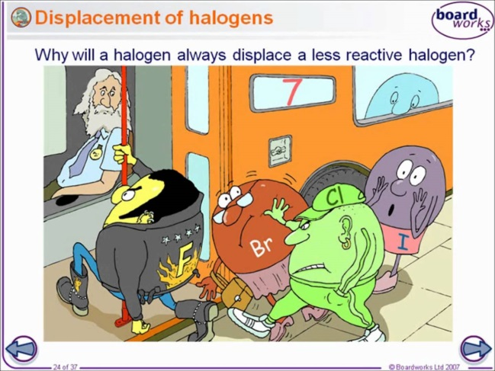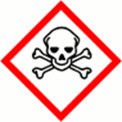

**Group 7(VII) - the Halogens**

Group 7 a group of reactive non-metals. They are all diatomic.

*The Halogens have similar chemical properties because when they react an atom gains an electron to form a negative ion (anion) with a stable electronic configuration;* ***halogens 🡪 halides***

|  |  |  |  |  |  |  |
| --- | --- | --- | --- | --- | --- | --- |
| **element** | **Reactivity** | **ion** | **state** | **colour** | **Formula of molecule** | **toxicity** |
|  |  |  |  |  |  | High |
|  |  |  |  |  | High |
|  |  |  |  |  | High |
|  |  |  |  |  | High |

Specials

* solid iodine sublimes on heating (turns straight from solid to a gas)

<https://www.youtube.com/watch?v=Ft2KgtlP8Lk>

* Test for Chlorine Gas (damp universal indicator paper changes to red and then bleaches white) <https://www.youtube.com/watch?v=DS1i4f8lUm8>

**Half equations (Higher tier only)**

Half equations are equations that include **electrons (e-)**We construct them as follows;

|  |  |
| --- | --- |
| Step 1 | Write down the reactant and product |
| Step 2 | Balance the atoms |
| Step 3 | Write the total charge underneath each part of the equation |
| Step 4 | Balance the charge by adding electrons |

1. Write a balanced half equation of the following conversions:

|  |  |  |  |  |  |  |  |  |
| --- | --- | --- | --- | --- | --- | --- | --- | --- |
|  | F2 🡪 F- |  | Cl2 🡪 Cl- |  | Br- 🡪 Br2 |  | I- 🡪 I2 |  |
| Step 1 |  |  |  |  |  |  |  |  |
| Step 2 |  |  |  |  |  |  |  |  |
| Step 3 |  |  |  |  |  |  |  |  |
| Step 4 |  |  |  |  |  |  |  |  |

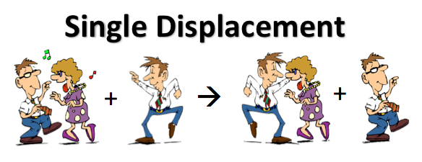

In a displacement reaction, a more reactive element replaces a less reactive element in a compound.

e.g. Potassium chloride + Fluorine 🡪 Will react;

1. What would you see? A yellow-green gas appears.
2. Complete the word equation;

Potassium chloride + Fluorine 🡪 potassium fluoride + chlorine

1. Write a balanced **symbol** equation for this reaction

2KCl + F2 🡪 2KF + Cl2

but

Potassium chloride + Bromine 🡪 Will **not** react

1. Explain why?

Bromine is less reactive than chlorine.

**Group 0 – The Noble gases**

These are a group of unreactive colourless gases. They are unreactive as their atoms are stable because they have full outer electron shells. The boiling point of the Nobel gases increases going down the group;

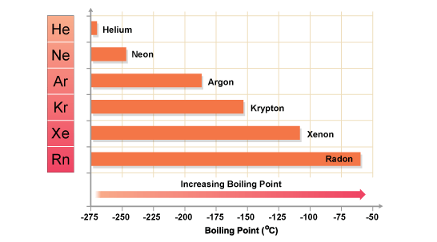

**The Transition metals**

The transition elements form ions with different charges (for example Iron(II) and Iron(III)). You can find the charges of any we need to know on the back of the Periodic table. Transition metals form coloured compounds

* copper(II) oxide is ……………………;
* copper(II) carbonate is ……………………;
* hydrated copper(II) sulfate is …………………; (*anhydrous Copper sulphate is white but adding water blues it blue – Chemical test for water*)
* copper(II) salts are usually ………………. in solution.

**Explaining the reactivity trends of Group 1 and Group 7**

Group 1 metals are reactive because they only need to ………. 1 electron. They get more reactive as you go …………. the group.

[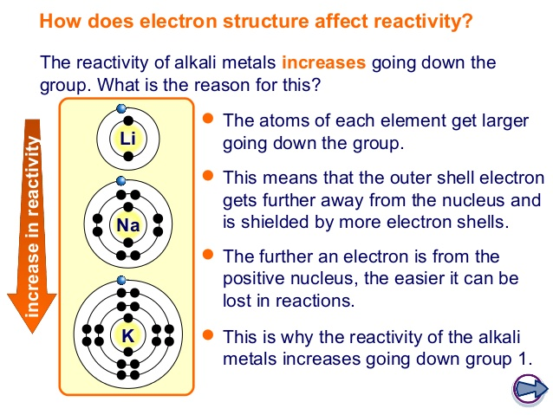](https://www.google.co.uk/url?sa=i&rct=j&q=&esrc=s&source=images&cd=&ved=2ahUKEwiPm4WR4IHgAhV4ShUIHdg3AWwQjRx6BAgBEAU&url=https://www.slideshare.net/shaunoff/2-group-1-15526771&psig=AOvVaw1N1qPkhxjYQNkRTkfIcSAE&ust=1548258926275047)Group 7 non-metals are reactive because they only need to …………. 1 electron. They get more reactive as you go …………. the group.

The trends are explained by the increasing number of energy shells as you go down a group and the increased distance from the positive nucleus.

* Going down the group the atoms get bigger
* The outer electrons are further from the positive charge of the nucleus
* The outer electron is less strongly attracted to the positive nucleus, so is easier to lose

[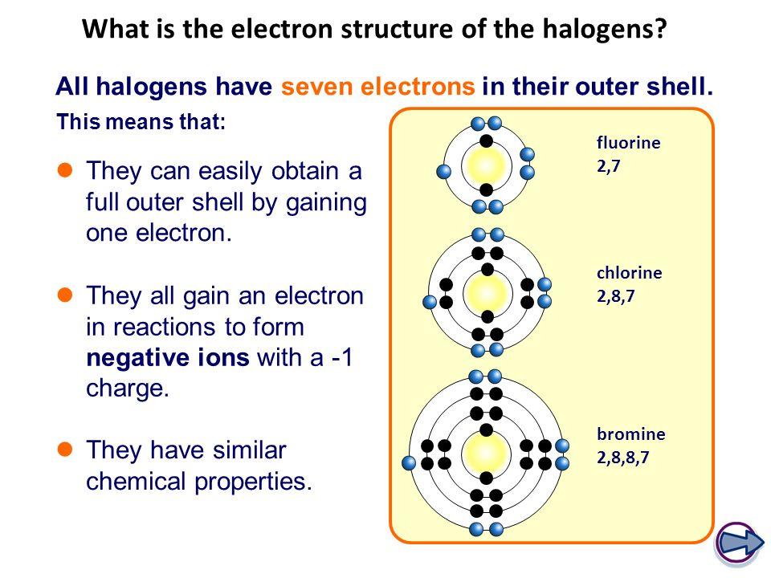](https://www.google.co.uk/url?sa=i&rct=j&q=&esrc=s&source=images&cd=&cad=rja&uact=8&ved=2ahUKEwjSj62X4YHgAhWFWxUIHbEsD-IQjRx6BAgBEAU&url=https://slideplayer.com/slide/8489547/&psig=AOvVaw1_jetTRD7KlJDXbpT0RNzQ&ust=1548259206495504)Using the diagram, explain why the Halogens get less reactive as you go down the group;

…………………………………………………………………………………………………

…………………………………………………………………………………………………

…………………………………………………………………………………………………

…………………………………………………………………………………………………